

Basic configuration for a simple service for on-prem 3scale

Introduction 2

Goals 3

Pre-Requisites 3

Step: Expose backend service as a managed endpoint 3

Step: Openshift related configuration and checks 13

Step: Testing the service 19

Step: Setting up metering and monitoring 23

Step: View Analytics and test authentication 30

Step: Application plans and policy enforcement 31

Step: Create a Swagger doc 35

Step: Create a basic developer portal 40

Step: Basic customization of the Developer Portal 59

Appendix 1 – Swagger 71

Appendix 2 – Dev Portal Swagger JavaScript 73

# Introduction

This workshop introduces you to some basic configuration of the on-prem version of 3scale briefly touching on the main areas of functionality. We will loosely base it on a basic POC we would normally roll out.

# Goals

1. Integrate this simple ***unmanaged*** API Endpoint into 3scale   
   <https://tc-apis.herokuapp.com/flights/intl/flights>   
   (**Note, this is a test API on Heroku. The first time it is hit every hour is slow)
2. Demonstrate the main 3scale API Management features typically required for a *basic POC* – including
   1. Access Control
   2. Policy Enforcement
   3. Analytics
   4. Swagger & Basic Developer Portal Configuration
3. Gain familiarity with the 2 Web Portals 3scale exposes
   1. Admin Portal. Used by: The API Provider – or organization ***exposing*** the API, e.g. United Airlines.
   2. Developer Portal. Used by: API consumers, e.g. Sites and mobile Apps ***using*** the APIs – e.g. Expedia, CheapOAir etc.

# Pre-Requisites

An On Prem 3scale API Manager – running on Openshift. This can be on a laptop, desktop, VM, public or private cloud.

# Step: Expose backend service as a managed endpoint

1. You have registered with 3scale and have installed 3scale all components on your on-prem env (say openshift) and are able to login to the console as admin/3scaleUser (instructions in doc titled<>)

1. Login to your 3scale API Manager using user *admin* and password generated or set during the deployment process. (If using above document to deploy on Openshift, username:password= admin/3scaleUser

https://3scale-admin.amp.<YOURIP>.xip.io/apiconfig/services

1. Integrate an API endpoint.
   * Navigate to: API > Create Service
   * Provide a name for your service and a system name say myflightservice.

Scroll down the page. For security settings, you can choose to go with the API key (left most option for now).

So the APIs link now has the service MyFlightService now created

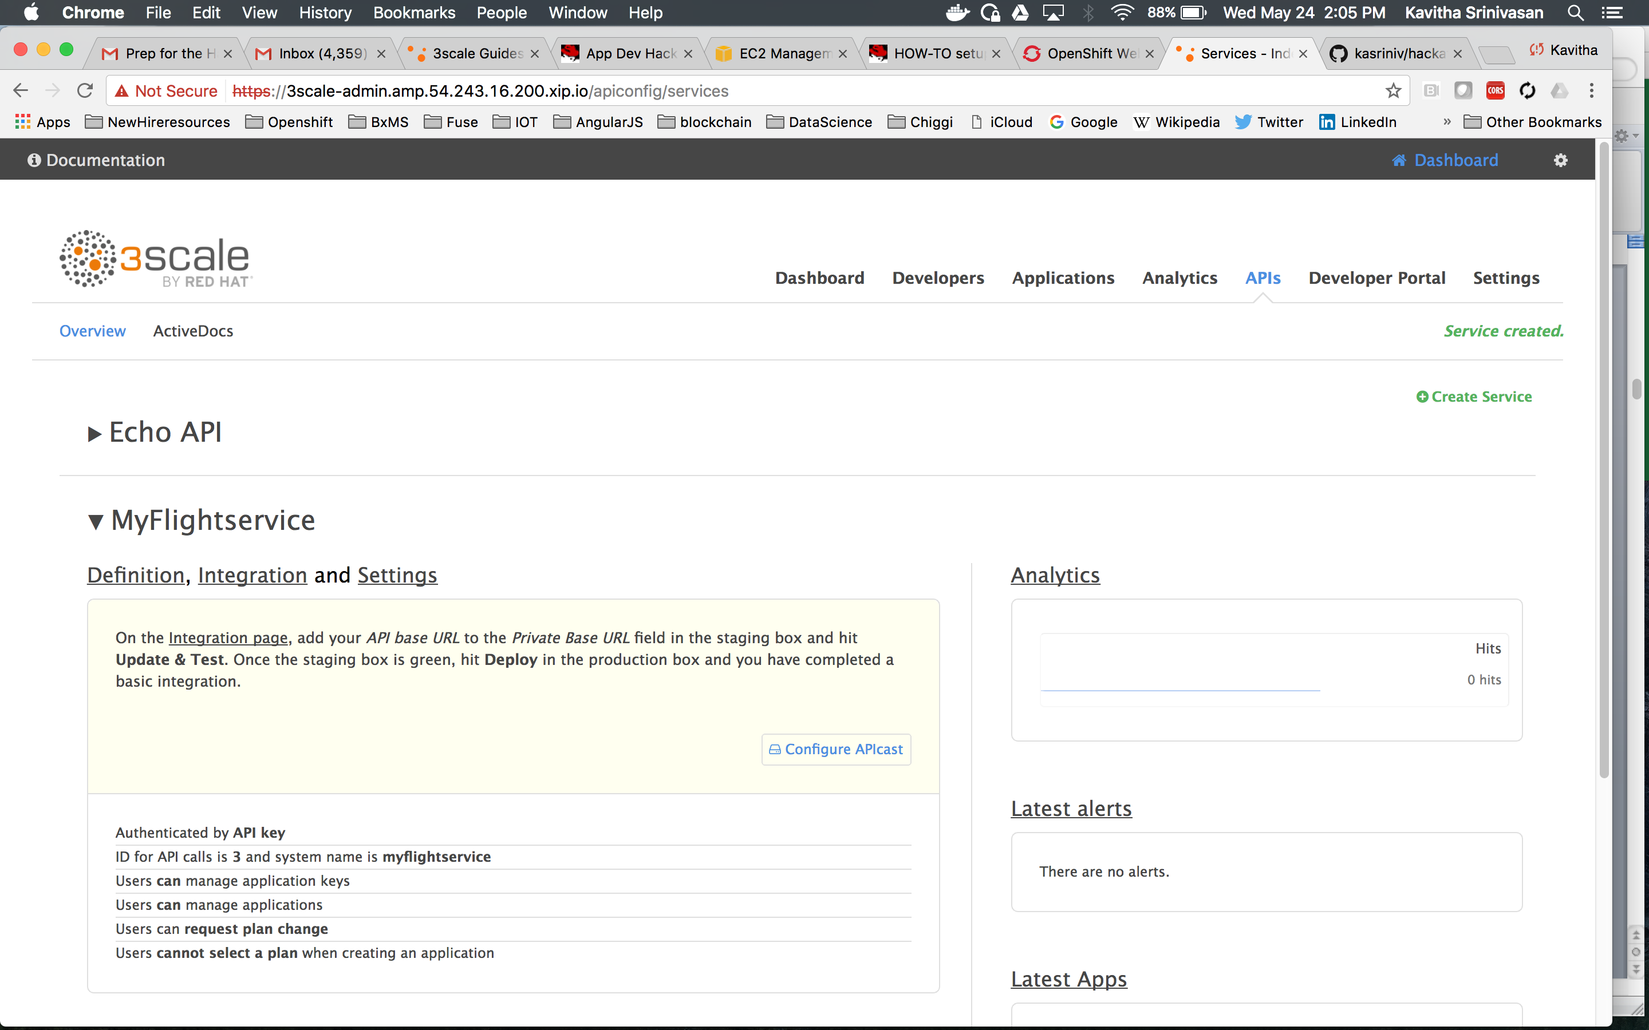

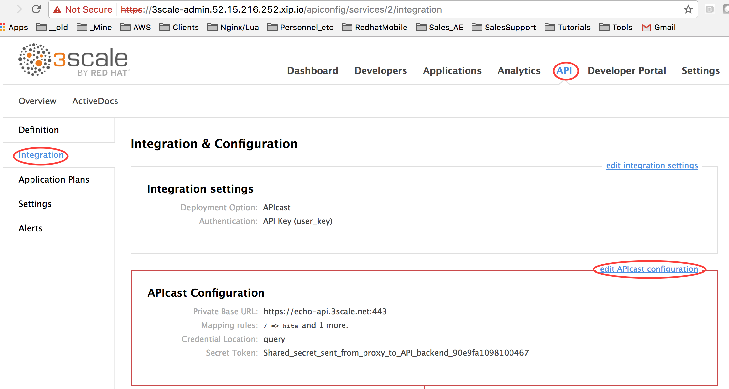

* This is where you configure your gateway, which will communicate with the 3scale Platform. Make the following entries:
  + - Private Base URL*: <https://tc-apis.herokuapp.com:443>  
      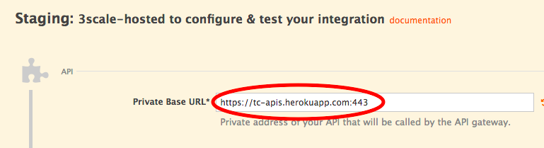  
        
      After entering this, click *Update & Test Staging Configuration* towards the bottom of the page (you are about to leave this page momentarily so this is necessary to save your Private Base URL)  
      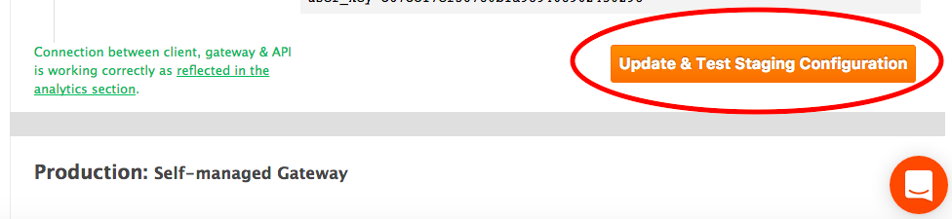
    - API Keys:

To test this application, we need API keys. Here are the steps to get a API key to access myflighttest service

* Go to API>Integration>Application Plans and click ‘create application plan’ and call it say ‘flightAppPlan’

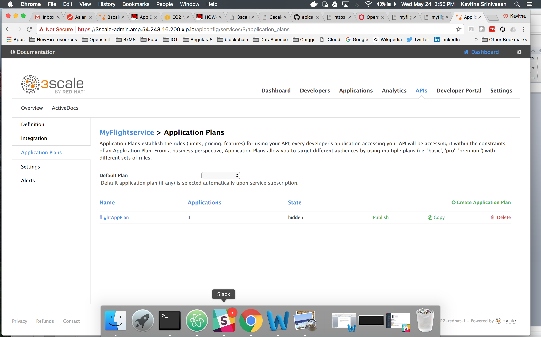

* Next, we will create an application and assign the application to a developer. Follow steps below:
  + Go to Developers link on top. Then click on the ‘developer’ (seeded developer) and click ‘Applications’ on top. Create a new application ‘flight App’. For Application plan pick the flightappPlan created in the previous step. Once completed, the screen looks like this
  + 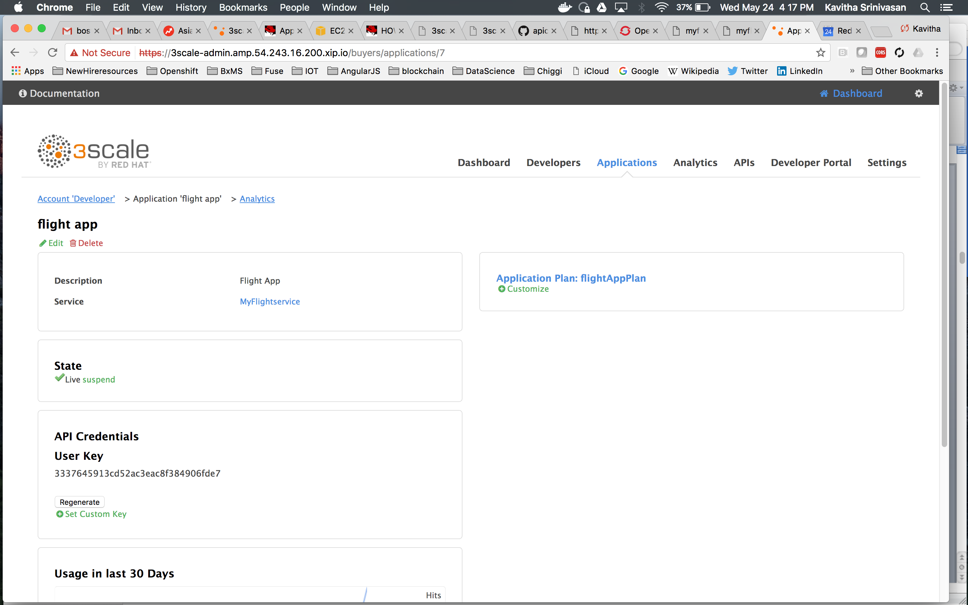
    - Go back to APIs (on top)>MyflightService>Integration>editAPICastConfiguration and add to the Client>API test getrequest section ‘/flights/intl/flights’ like in screenshot below

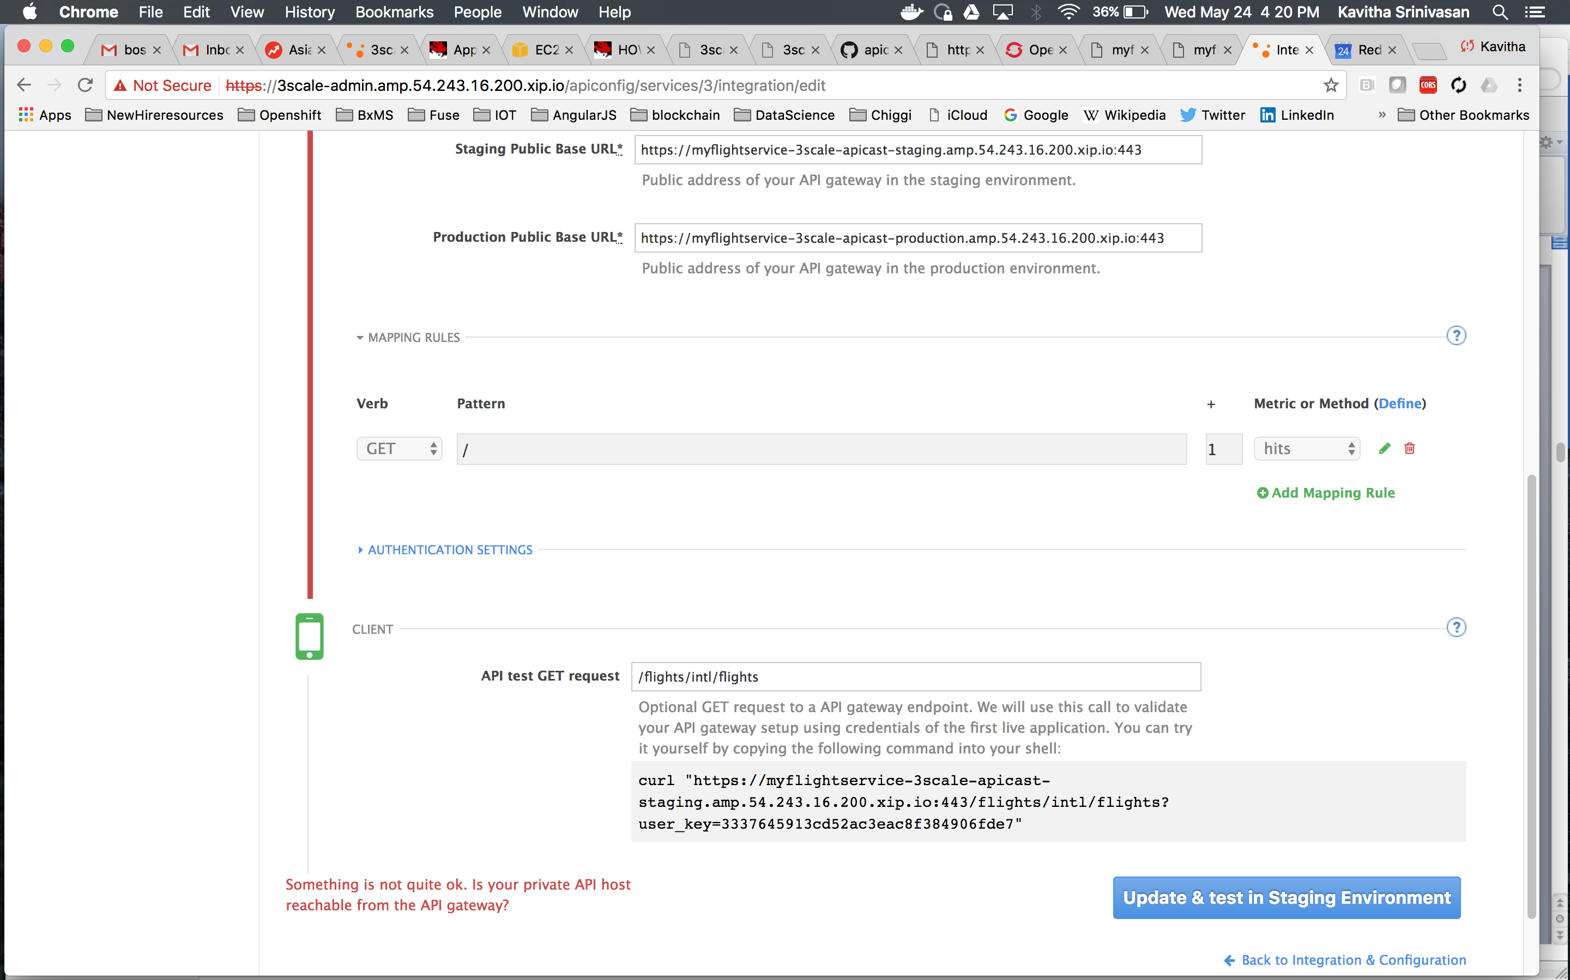

Click ‘Update and Test in Staging Environment’.

## Step: Openshift related configuration and checks

This section is relevant only if your deployment is on Openshift.

Create a route.

We will create 2 routes in Openshift that routes a request to a) the staging pod b) the production pod

1. Login to the Openshift console
2. Go to ‘Applications’ on the left panel and then click on Routes.
3. Click on ‘Create Route’ button

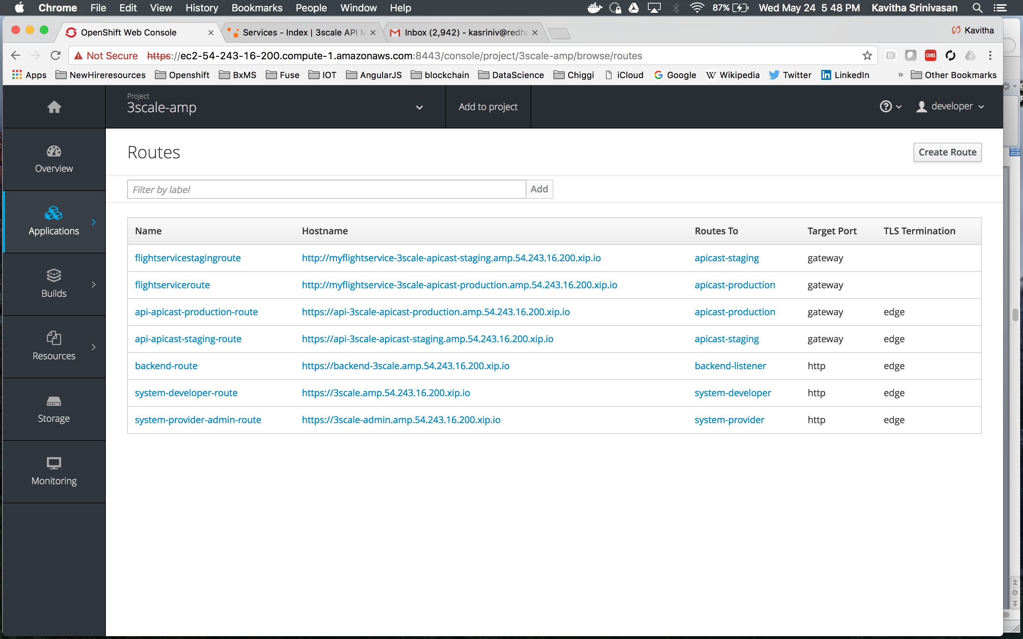

Now

On another browser window go to the 3scale admin console and find the public staging URL

Click path: APIs>MyflightService>Integration>APICast Configuration

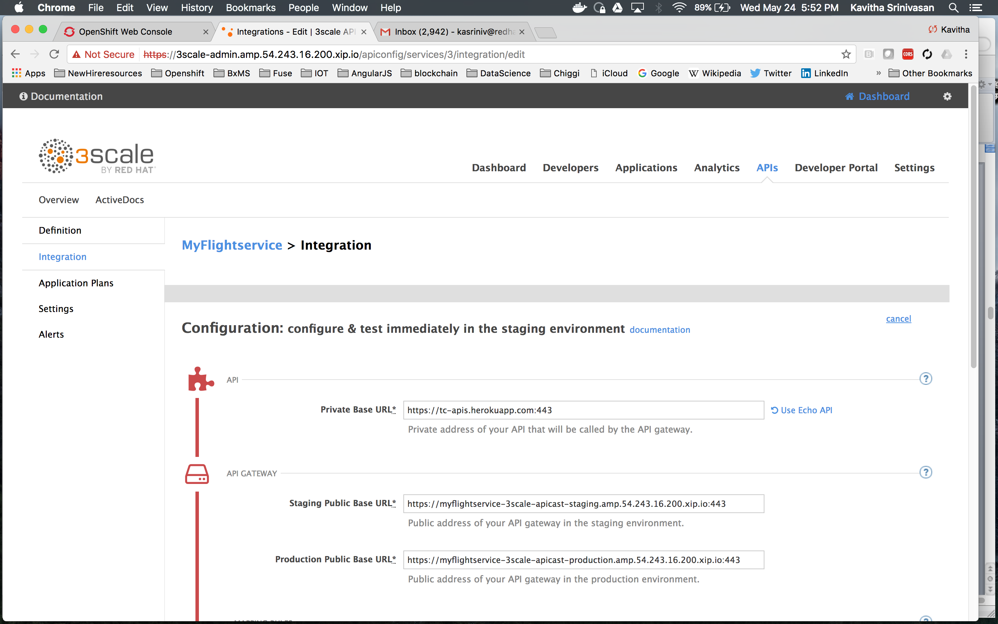

Note that the staging URL here is https://myflightservice-3scale-staging-amp.<myip>.xio.io:443

Now back to the OpenShift ‘Create Route’ screen:

Name: flightservicestagingroute

Hostname: myflightservice-3scale-staging-amp.<myip>.xio.io from the url from the 3scale admin console as above

Service: apicast-staging

Defaults for all other values

Once the service is created clicking on flightservicestagingroute looks like this:

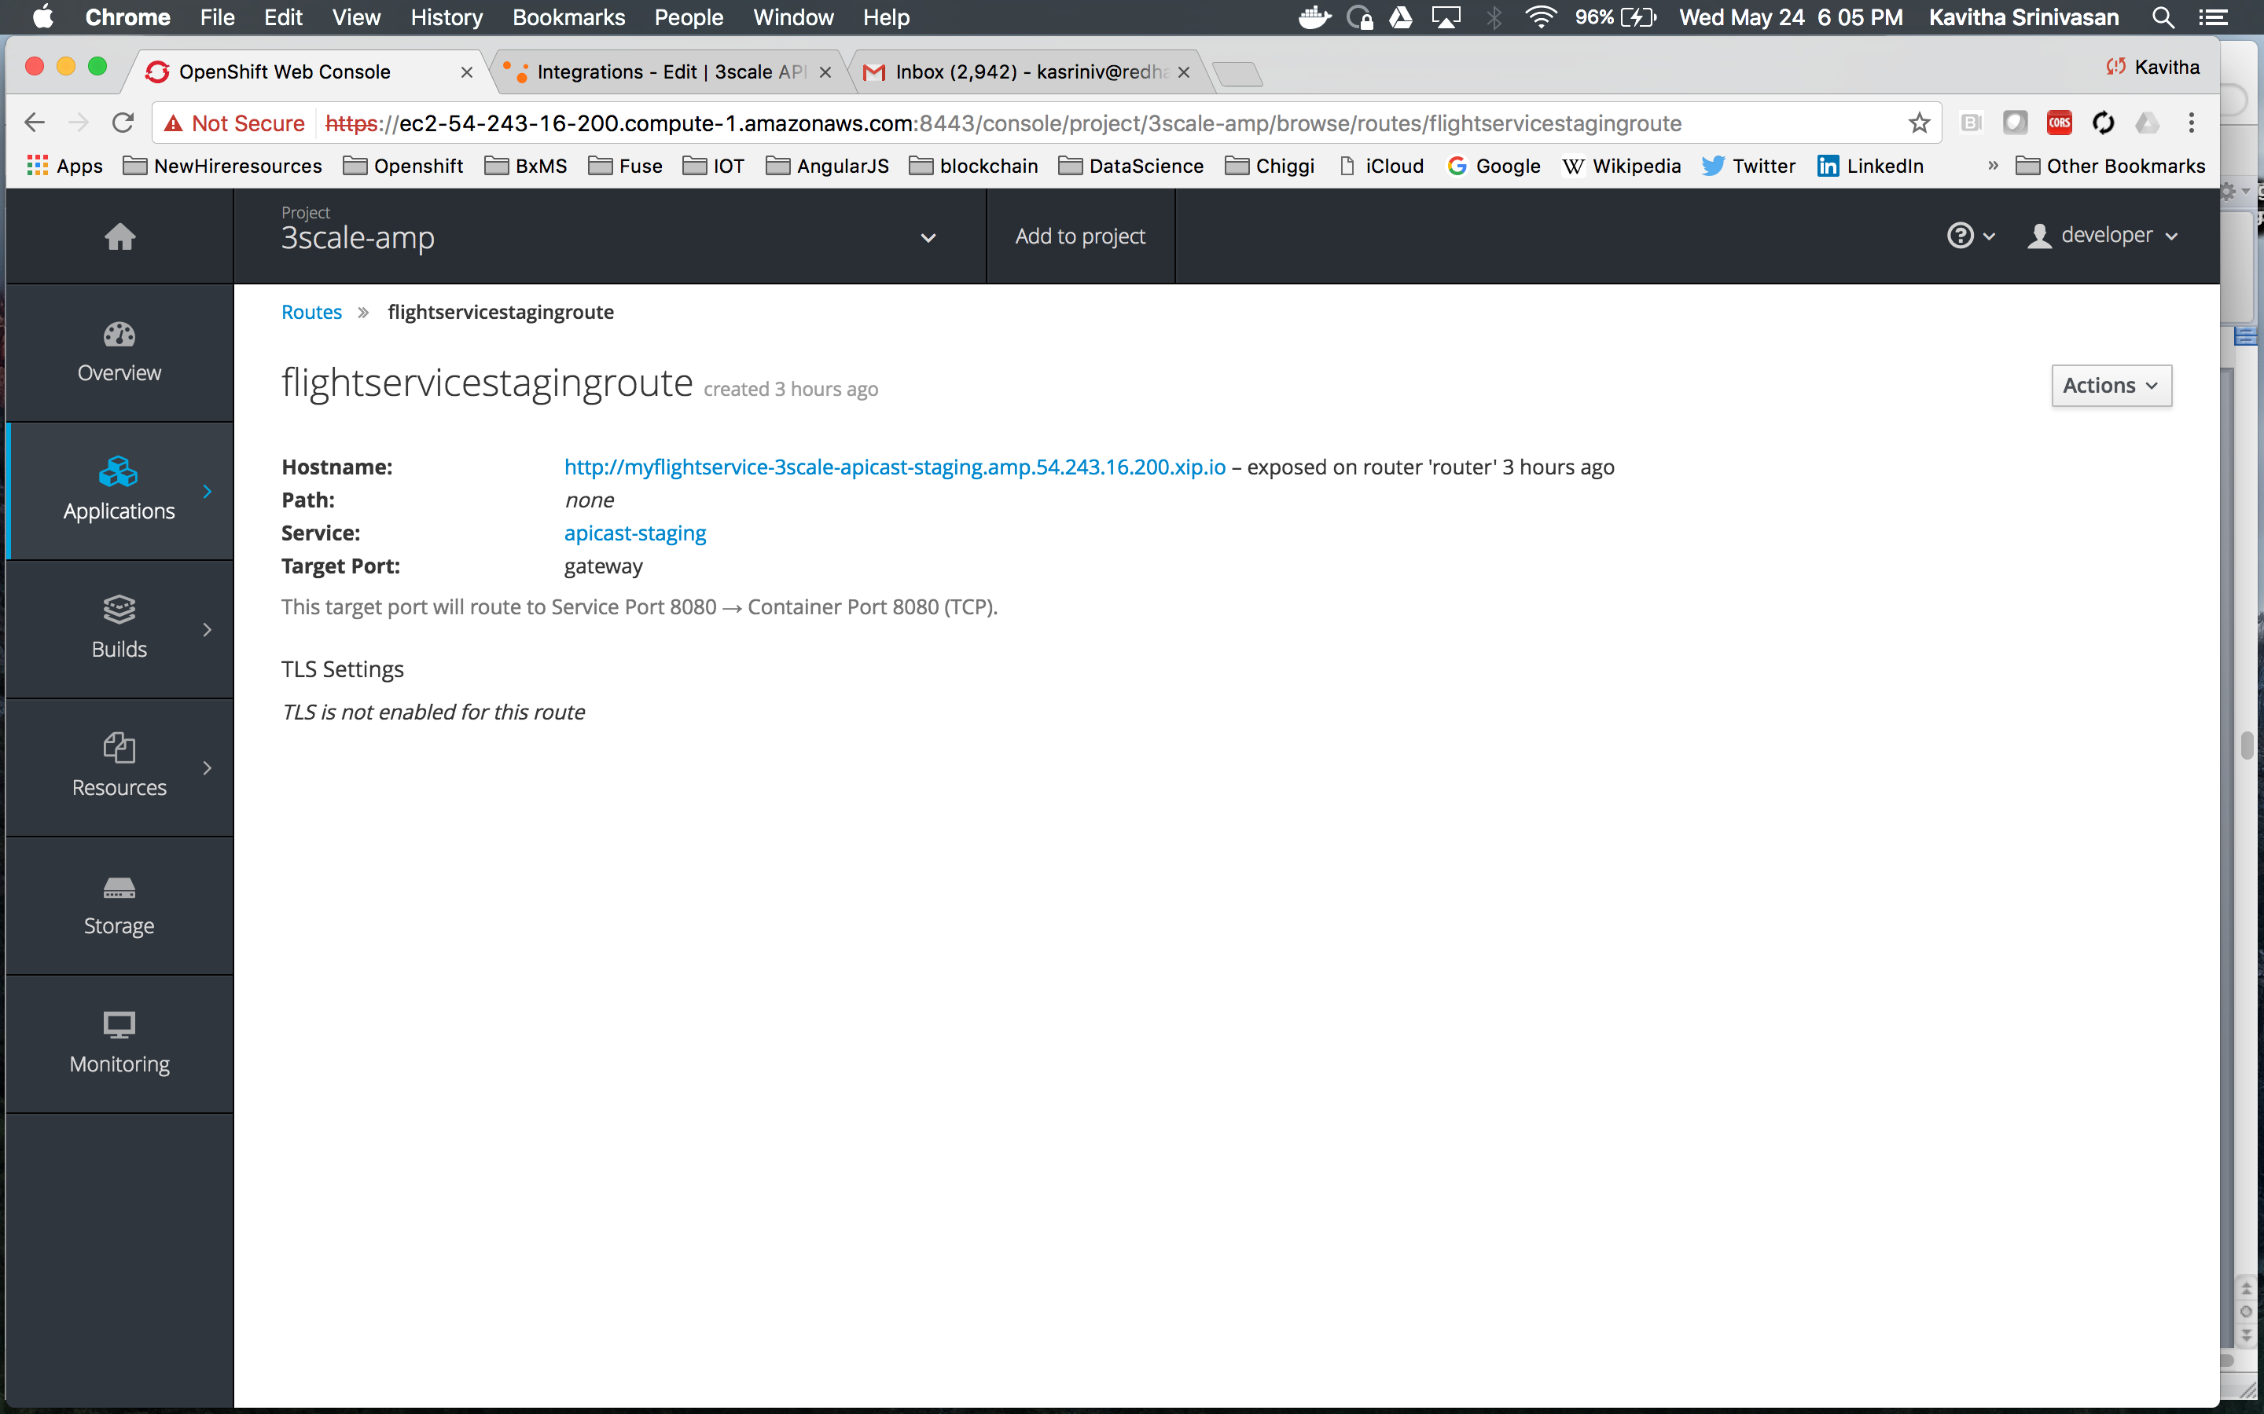

## Step: Testing the service

Before we move on to the rest of the features, we are going to quickly test accessing the service at the endpoint exposed by 3scale.

1. Go to the 3scale admin console, APIs>Myflightservice>Integration>edit apicast config and hit ‘Update and test in staging environment’.
2. Go to the Openshift admin console and deploy the pod again. Note a config property can be set by which the API config changes made will automatically be deployed onto the pod periodically.

For now, we will do this redeployment manually

Applications>Deployments

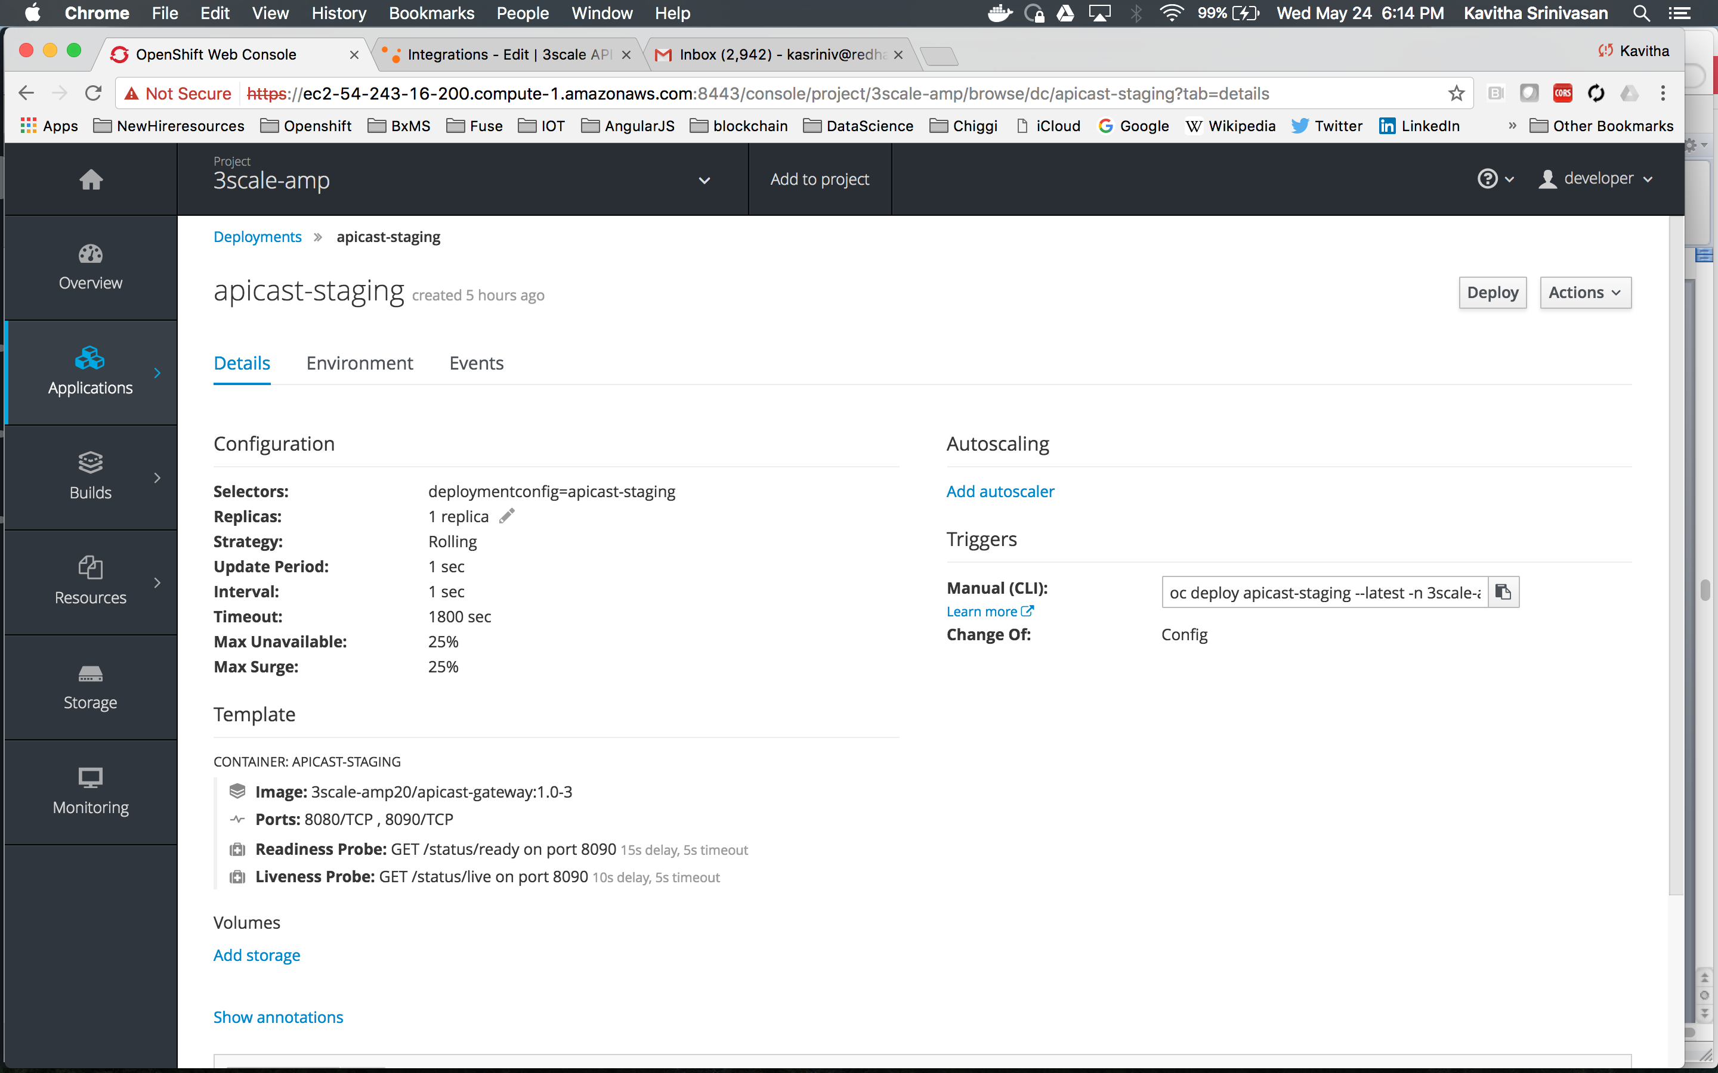

Hit Deploy and wait for deployment to complete.

Test using a browser and at the 3scale endpoint URL as such

[http://myflightservice-3scale-apicast-staging.amp.54.243.16.200.xip.io/flights/intl/flights?user_key=<youruserkey](http://myflightservice-3scale-apicast-staging.amp.54.243.16.200.xip.io/flights/intl/flights?user_key=%3cyouruserkey)>

You can get this from the curl command generated on the api config screen as well.

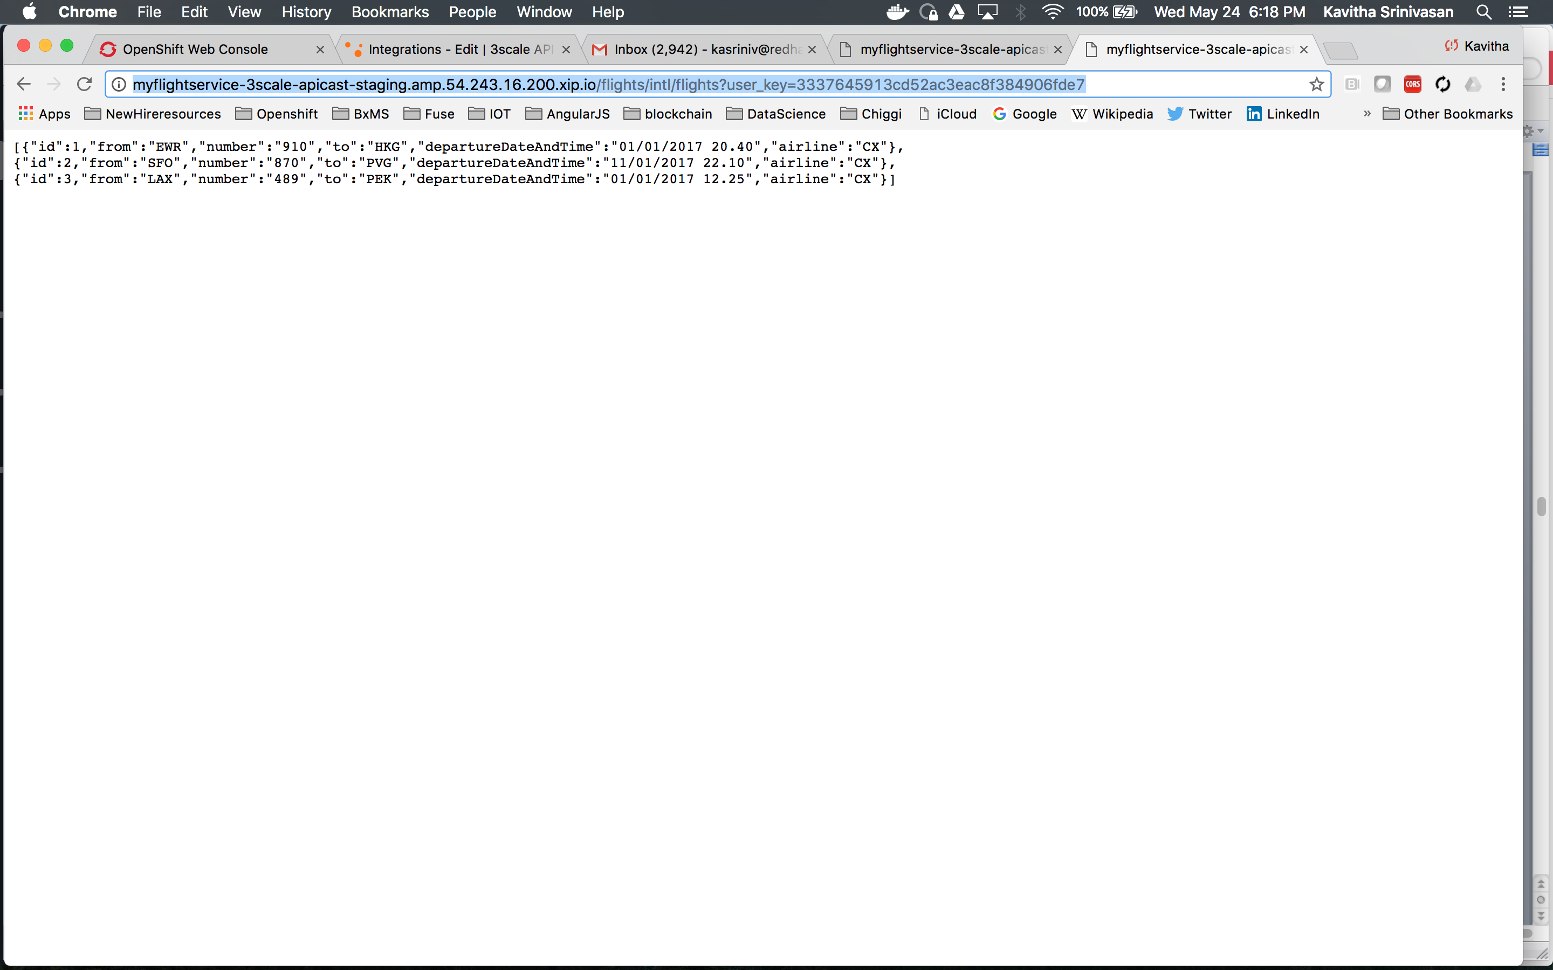

## Step: Setting up metering and monitoring

Now that we have established basic connectivity between components, lets move on to exploring more features like usage tracking, metering etc.

* + - Mapping Rules. This is where you map URL patterns of endpoints to ***Methods*** and ***Metrics*** (enabling you to track usage and control access)

Login to the 3scale console. Go to APIs>Myflighservice>Integrations>editapicastconfig

* + - * Define a Method (logical representation of an Endpoint) by clicking *Define*.  
        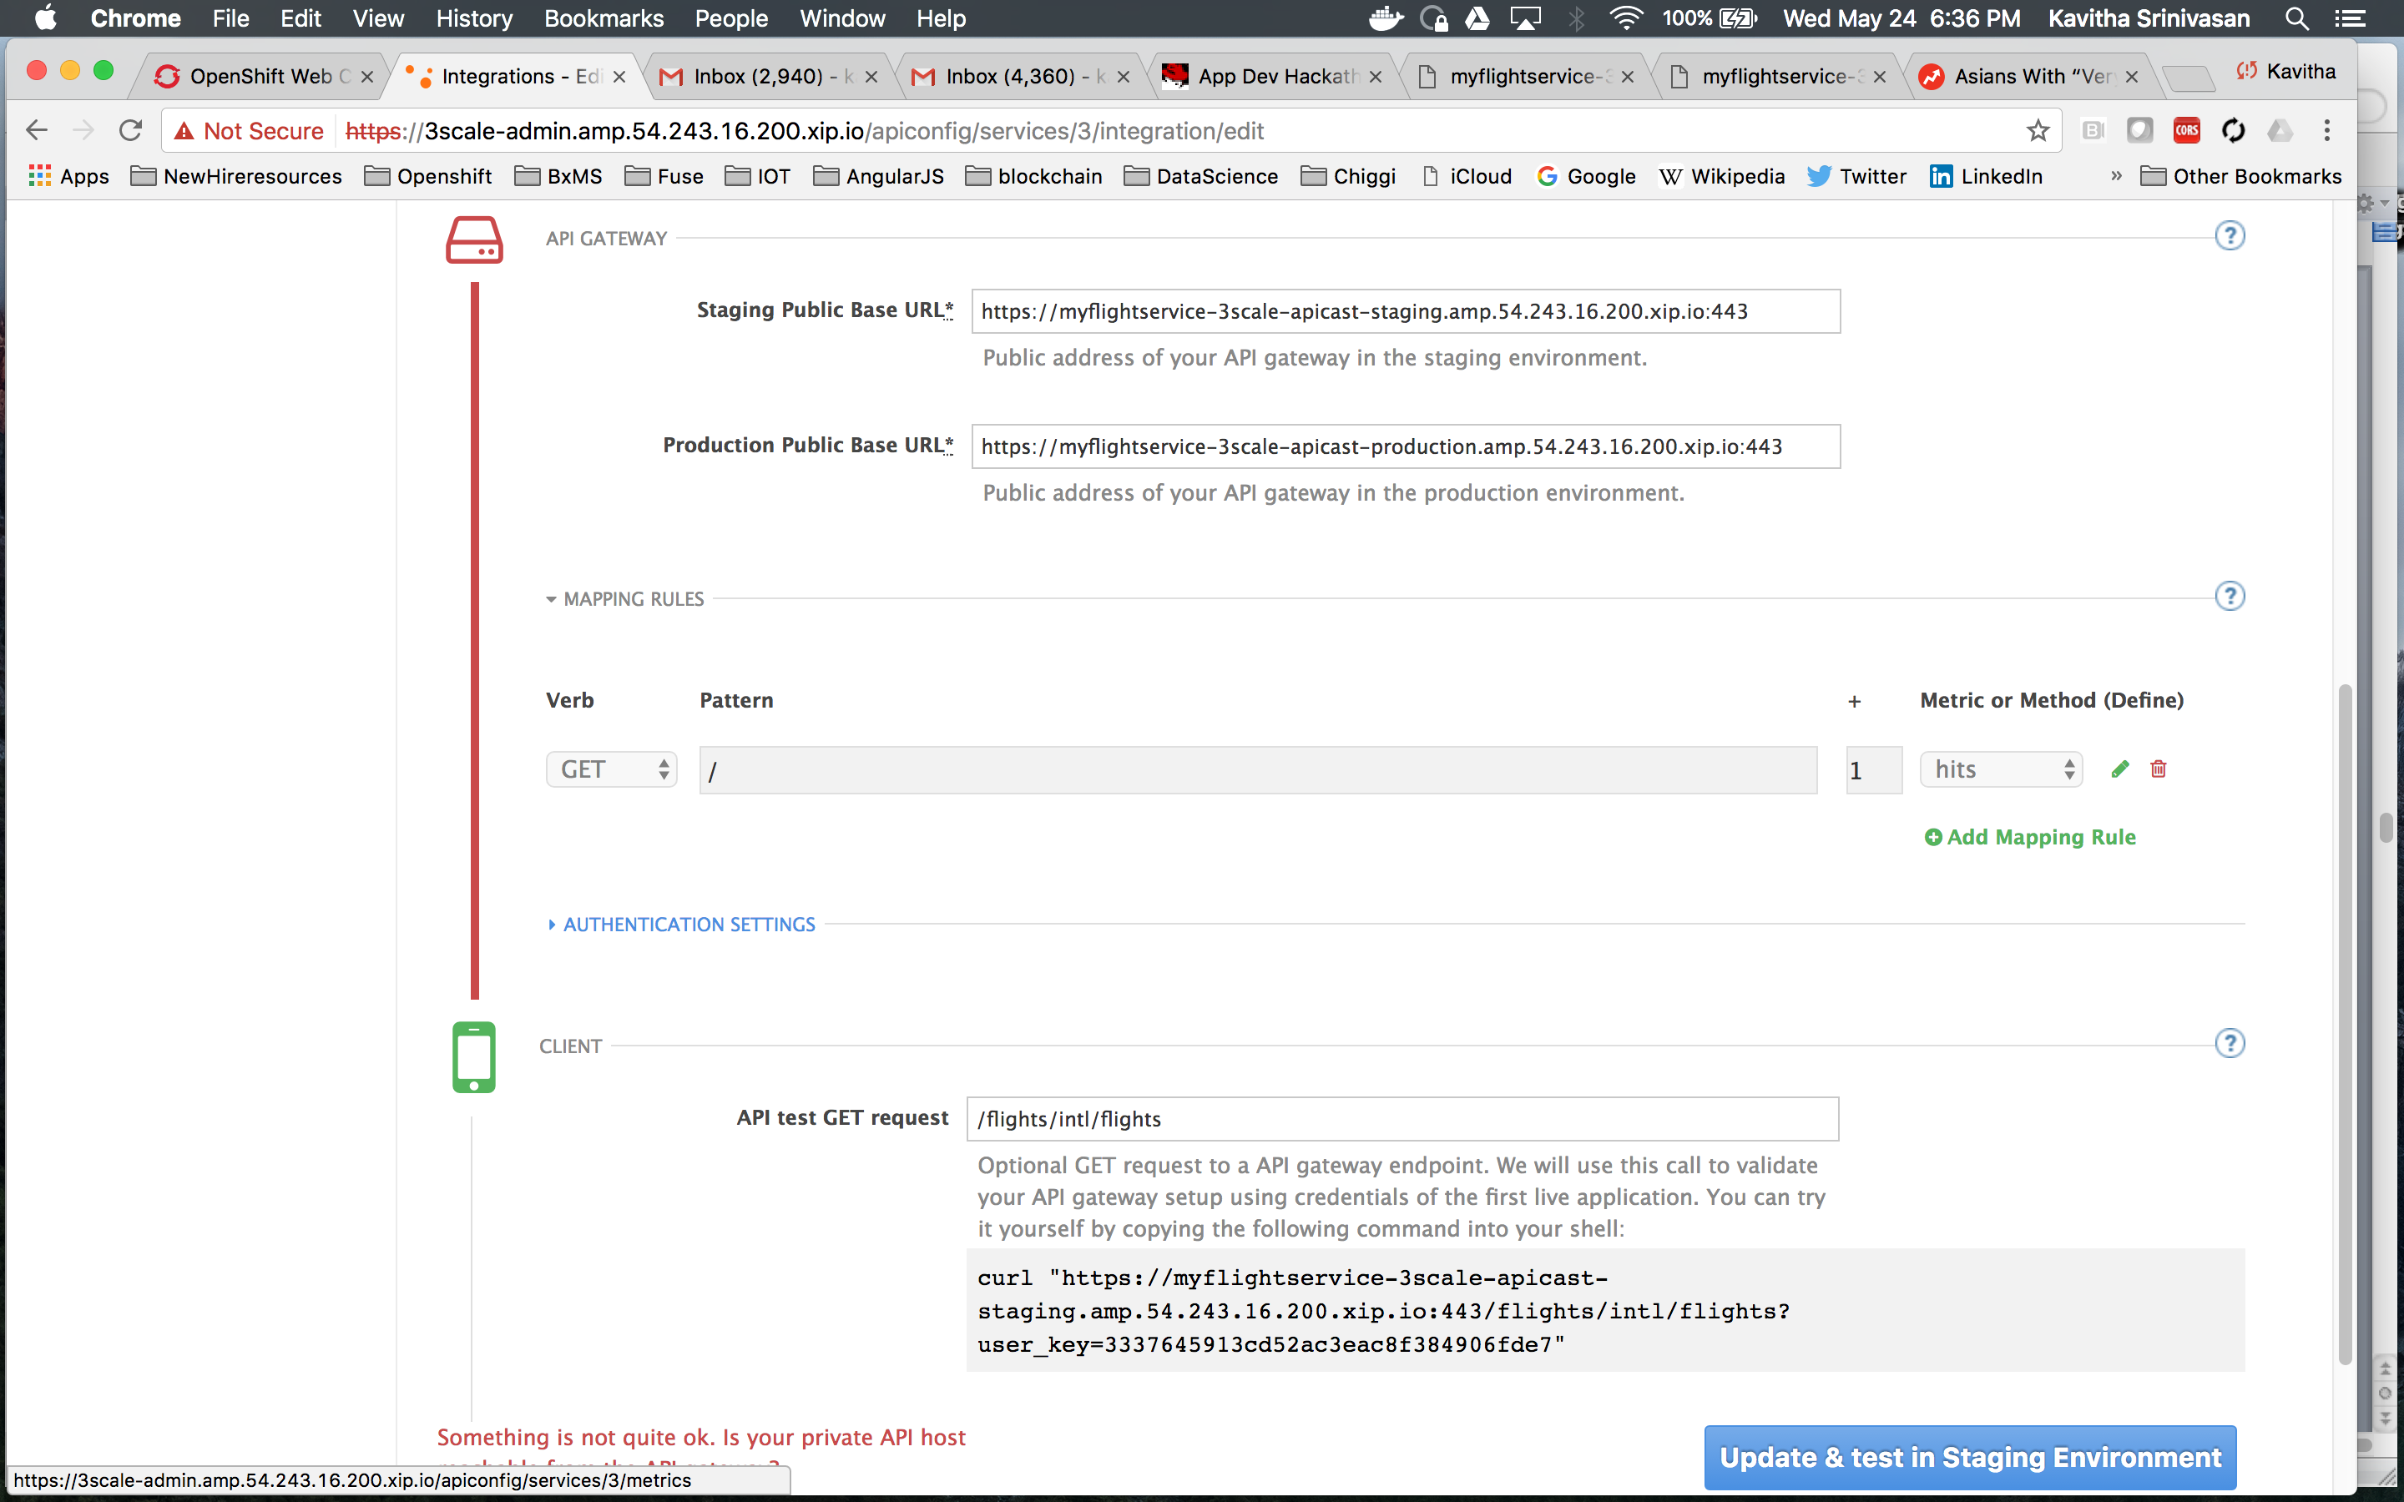
      * Create a *New Method*  
        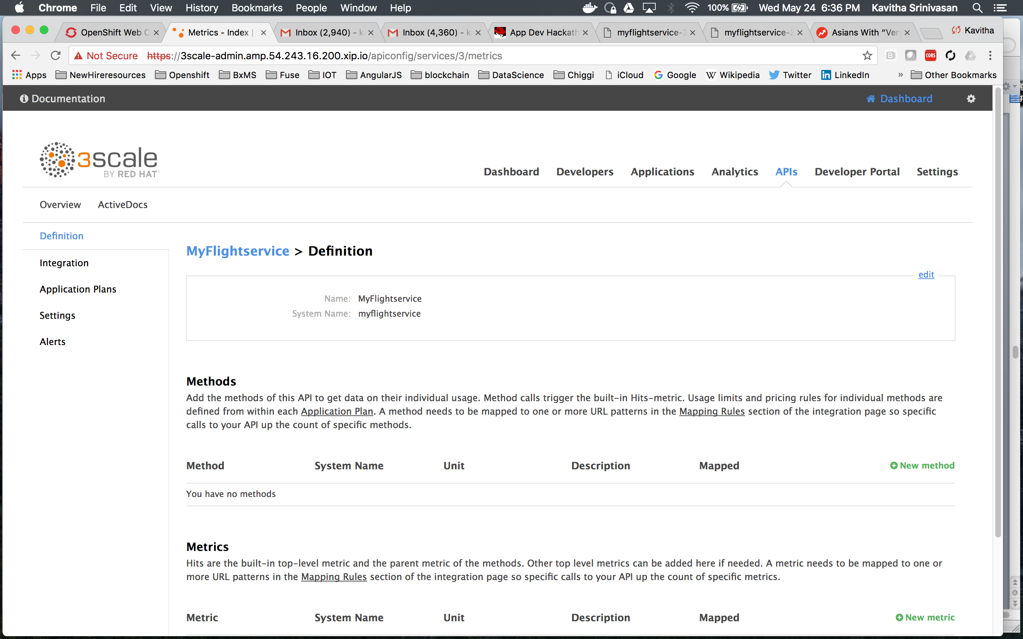
      * Name it something like Get Flights and *get-flights* (Friendly and System names). Create it.  
        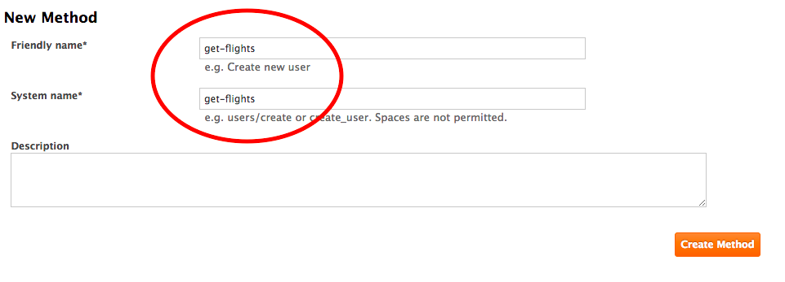
      * Add a Mapping Rule to it back on Integration screen.  
        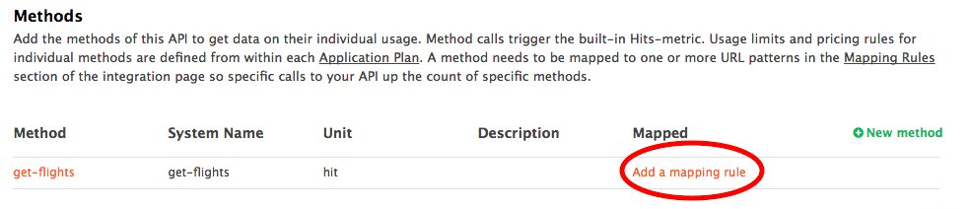
      * Replace the default Mapping to *hits* by editing it.  
        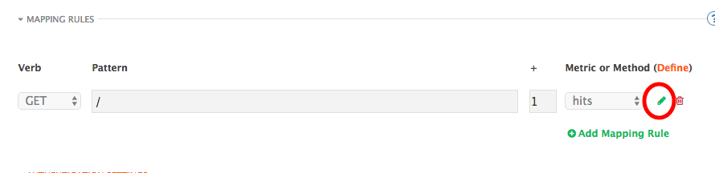

* + - * Replace the Pattern with the URL path to our endpoint (/flights/intl/flights) and select the new method *get-flights.* Use the same path (/flights/intl/flights) in *API test GET request* then click *Update and Test in Staging Environment*. 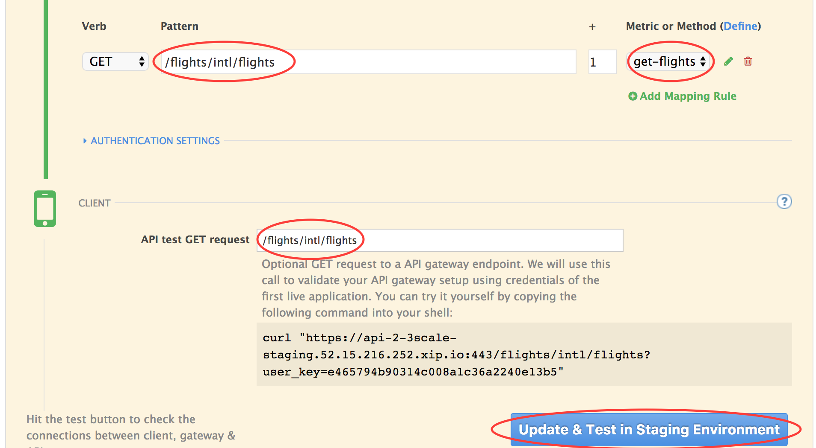
      * If all goes well, status will turn green – indicating your configuration has been deployed to your staging environment.

If not, you can simply redeploy the openshift api-staging pod.

* + - * You can now test your managed API endpoint using the curl or via the browser   
        (**Note, this is a test API on Heroku. The first time it is hit every hour is slow)

http://myflightservice-3scale-apicast-staging.amp.<YOURIP>.xip.io/flights/intl/flights?user_key=<yourkey>

## Step: View Analytics and test authentication

* Keep the Integration tab open and open another tab on Analytics -> Usage. Notice your method, *get*-*flights*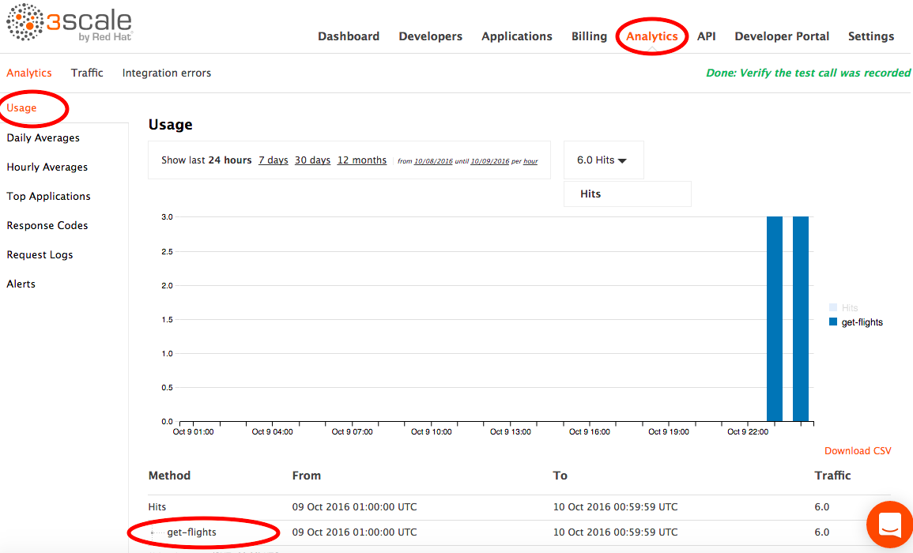
* Test Authentication.
  + - In a terminal (or browser), hit the URL in the curl statement on the Integration screen you worked on (above) - something like:   
      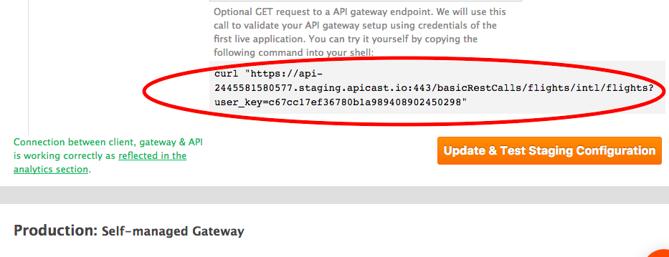  
      It should succeed.
    - Enter an incorrect user_key and retry, it should fail.
* Switch to your Analytics tab and refresh. The count for *get*-*flights* should have incremented

## Step: Application plans and policy enforcement

This illustrates how you can give different access rights to different classes of API Consumer.

THIS SECTION IS WORK IN PROGRESS. SKIP TO END OF WORK IN PROGRESS SECTION

* + Go to API -> Application Plans -> click the ‘flightapp plan’ previously created.   
      
    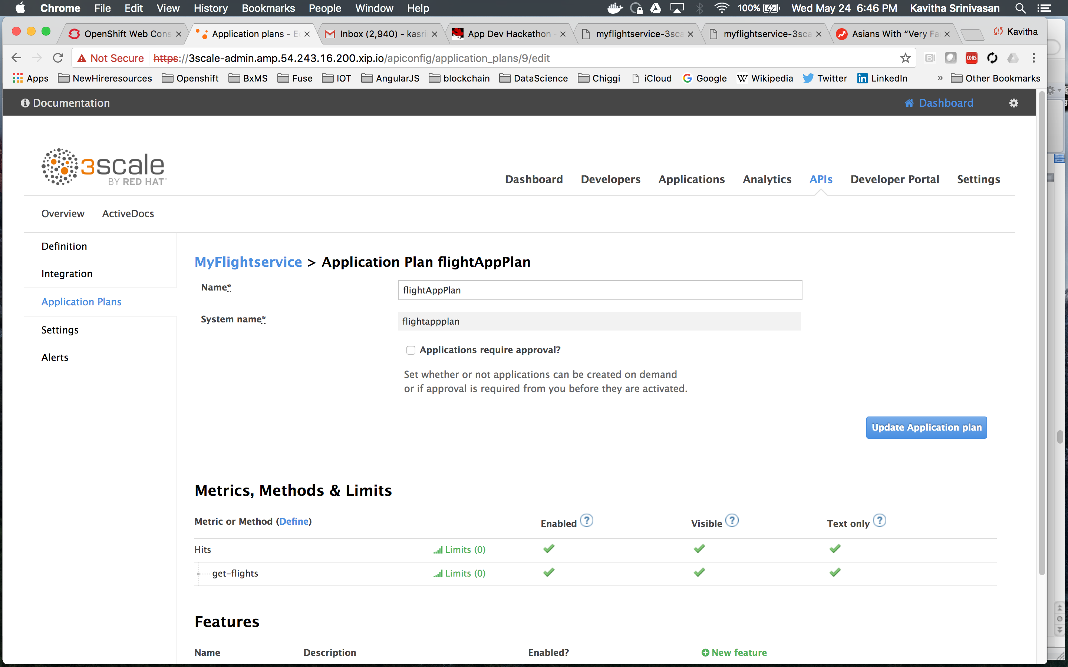
  + Disable method get-*flights* by clicking its *Enabled* check box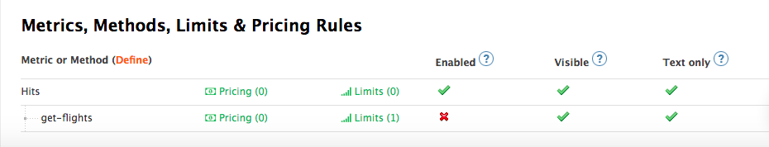
  + Go back to your terminal window and run the curl twice* but this step does “not” require Openshift pod redeployment.
  + Access will be denied   
    *requires 2 calls as policy information in the cache will show success from the previous call and allow the first through. The 2nd will use freshly populated data, cause a synchronous call to the manager and then block access.
  + Now we’re going to change the access rights this API consumer has. Open Applications -> then click on the Developer’s App.   
    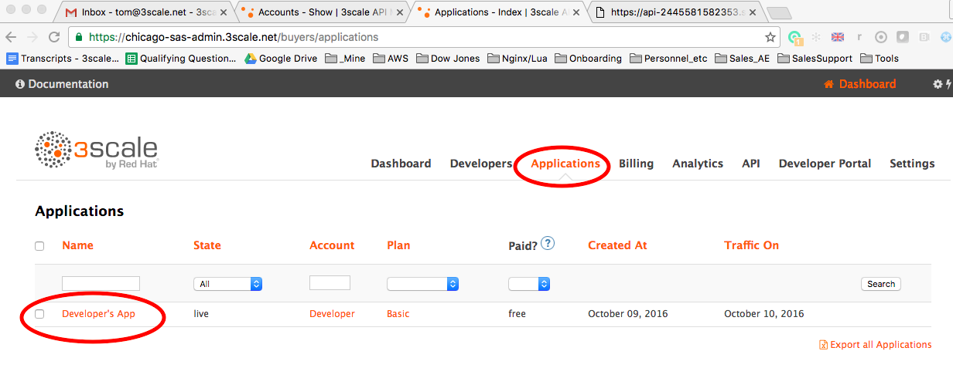
  + This *application* represents our API Consumer. You can see the User Key on the left – the one we’ve been attaching to our 3scale managed API calls. The access rights this consumer gets are defined by the Plan this Application subscribes to: ***Basic*** on the top right. The Basic Plan has disabled access to *get-flights* – hence we’re blocked as you’ve seen.   
    Now we’re going to change the level of access this Developer App has. Change the Plan to *Unlimited* – which does have access to 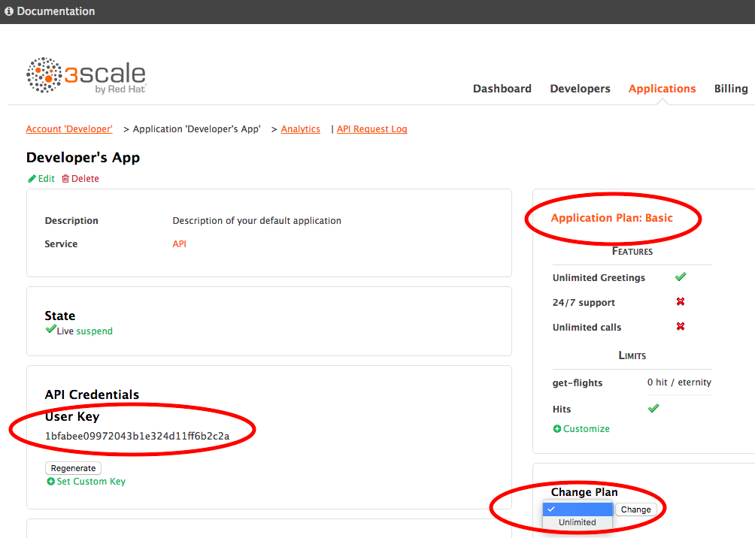
  + Go back to terminal and hit the API again – this time it succeeds as its policy, *Unlimited*, allows it.  
    **END WORK-INPROGRESS SECTION. YOU CAN PROCEED TO THE NEXT STEP BELOW**

## Step: Create a Swagger doc

* Swagger Configuration

3scale uses the popular API Documentation and testing tool Swagger. We’re now going to configure it then display it in the Developer Portal

* + - Open Active Docs menu item on the top left  
      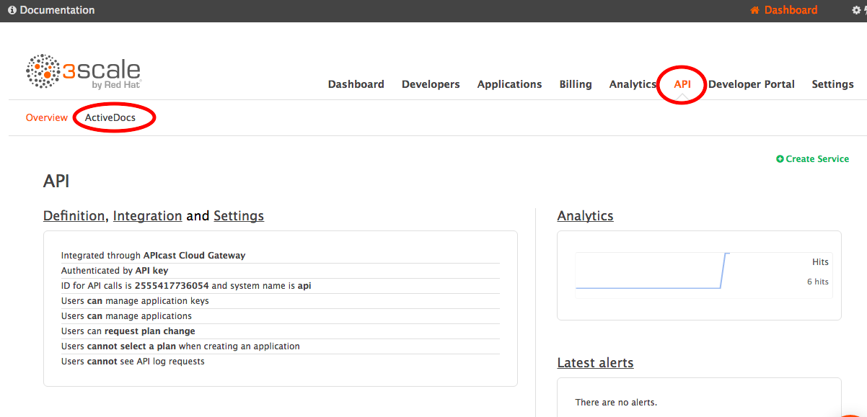
    - Open Echo link and the left and Delete it. This was created if you used the out-of-the-box echo service to test. You will not see it if it was not used and so can skip this step.  
      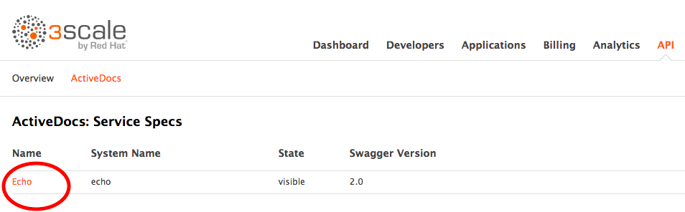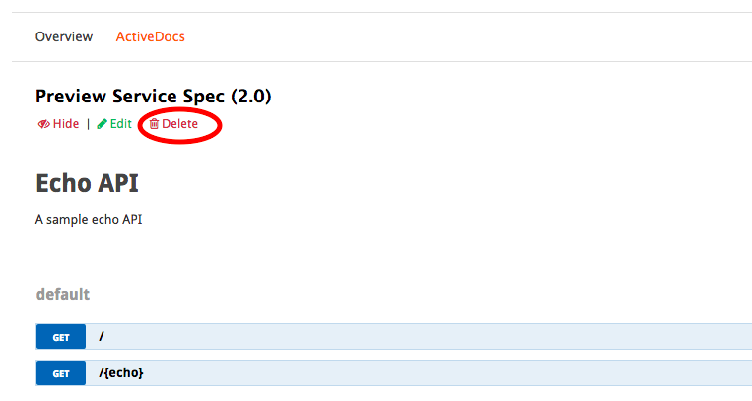
    - Create new Spec.  
       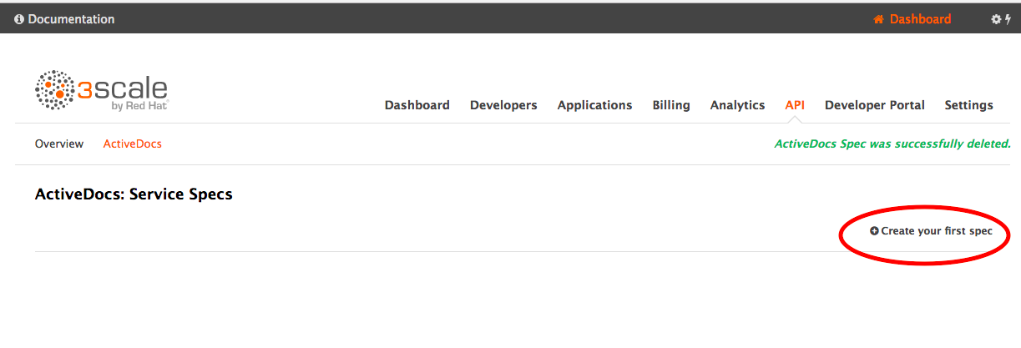  
      * Name it *flights-docs* (both Name and System Name) and **check the ‘Publish’ box**.
      * Paste in the JSON in Appendix 1 – Swagger below into *API JSON Spec\**
      * Replace the string ***yours.com*** with the host you've been using in your curls, e.g. api-2445581074662.staging.apicast.io
      * Create Service
      * Open it by clicking *flights-docs.* Expand the endpoint *GET /flights/intl/flights.  
        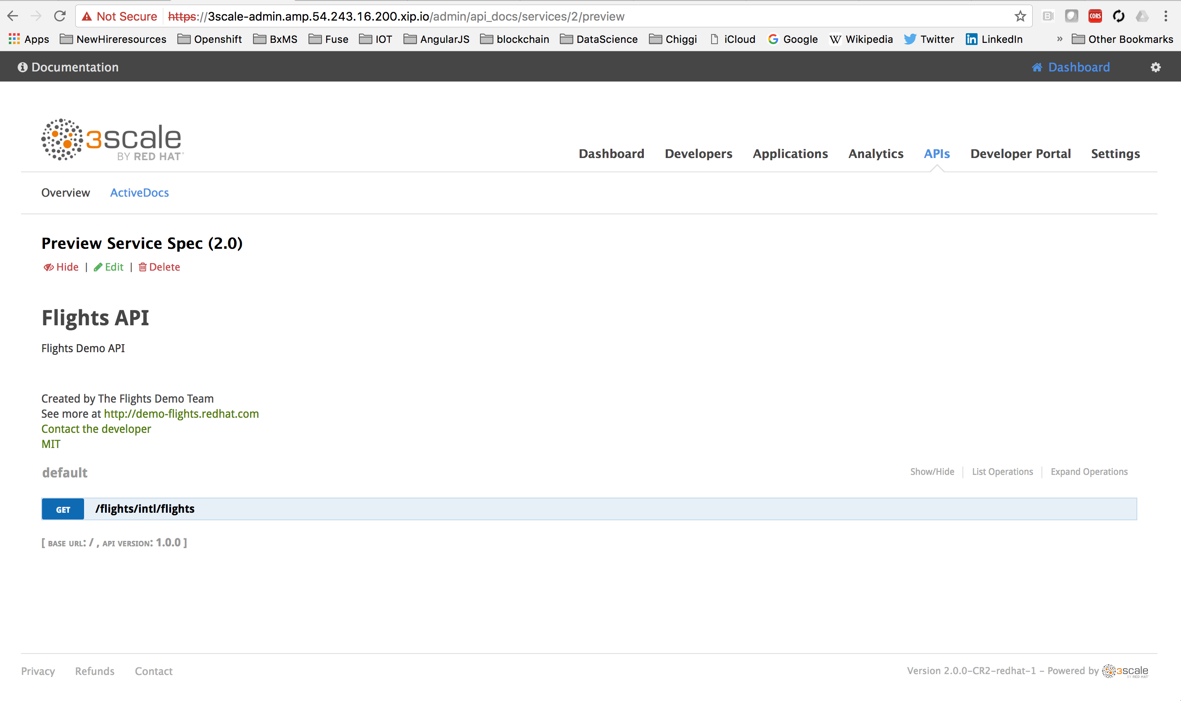*
      * Click in the user_key field (select key that pops up for the flightservice) and Try it out! (**Note, this is a test API on Heroku. The first time it is hit every hour is slow)  
        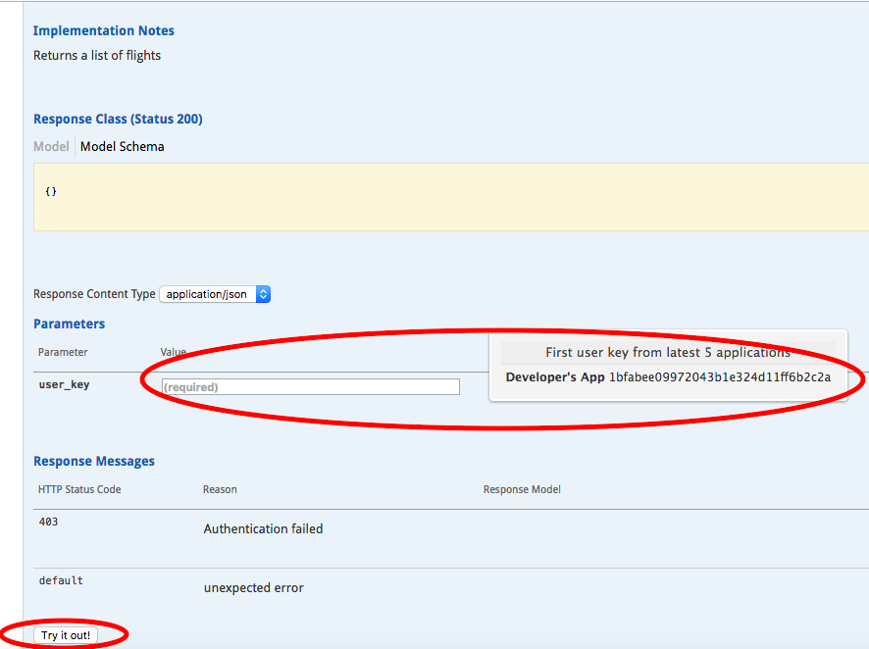

Test output screenshot here

## Step: Create a basic developer portal

* + Developer Portal.

Now we’re going to configure a page and a logo that will be ***viewable by an API consumer*** – in our example could be someone like Expedia or CheapOAir

Common POC Asks

Swagger in Portal

Custom Logo for API Provider – a very basic customization.

We will create a portal page, customize it and add a Swagger Page

* + - * Click on Developer Portal menu item then New Page ->New Page  
          
        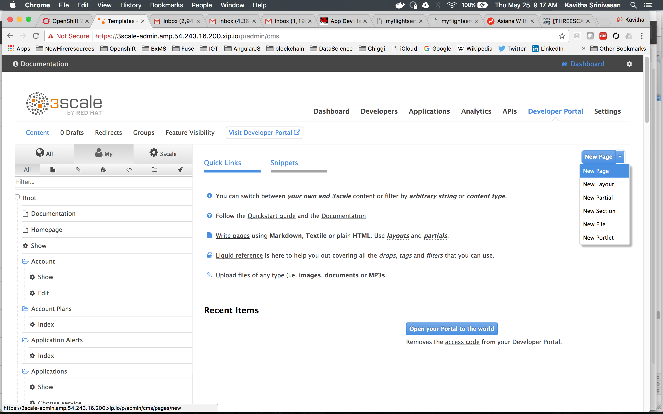
      * Fill it in as follows.

Add a name: MyFlightTestPage

Add Path: /testdocsExpand *Advanced options* and click *Liquid Enabled.*

*Your screen probably looks like this.*

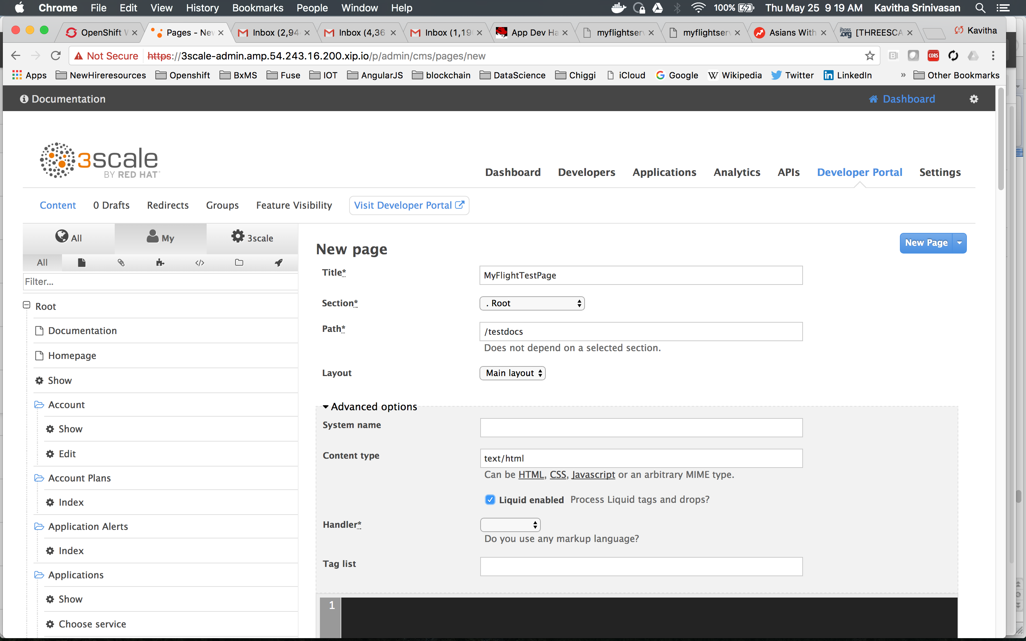Paste in Code snippet ( below in *Appendix 2 – Dev Portal Swagger JavaScript)*   
Replace "<system-name>" with your Swagger System Name above (5.a.iii.1), *flights-docs*Create Page  
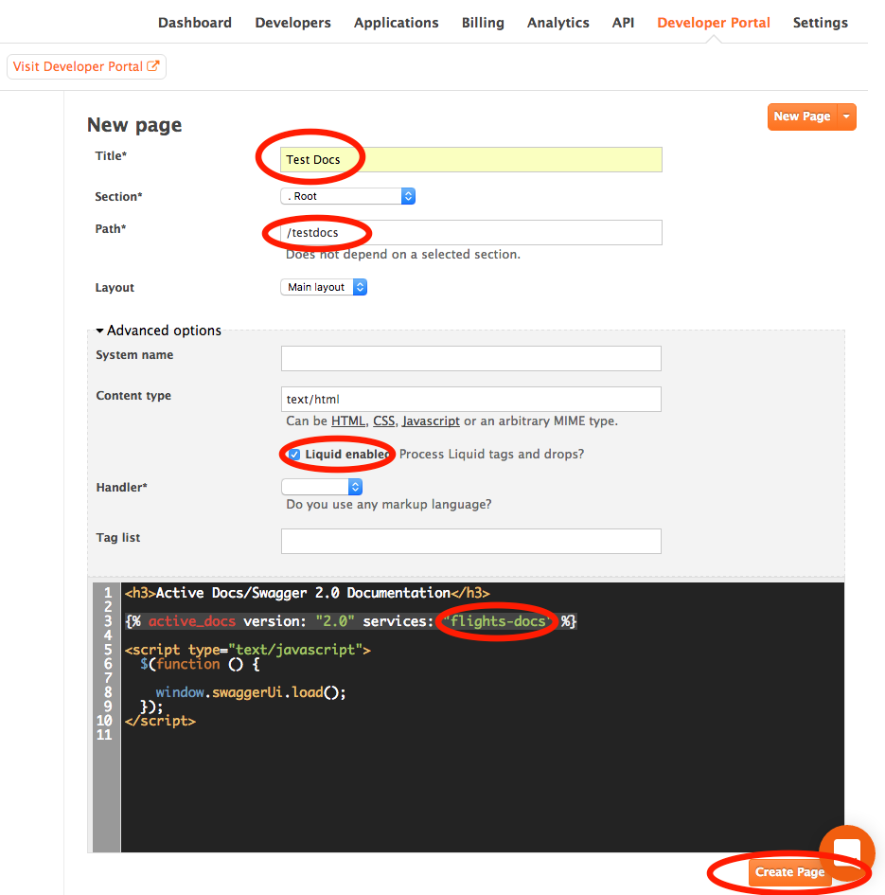

* + - * After Create Page, Publish it. Note there are 2 modes you can save in: Draft (clicking Save) and Published- obviously clicking Publish.  
          
          
          
          
          
        Now, we will create credentials for a developer so that <>
    - Set your Dev Portal credentials.
      * Open Developers menu item, then open the Developer Account.  
        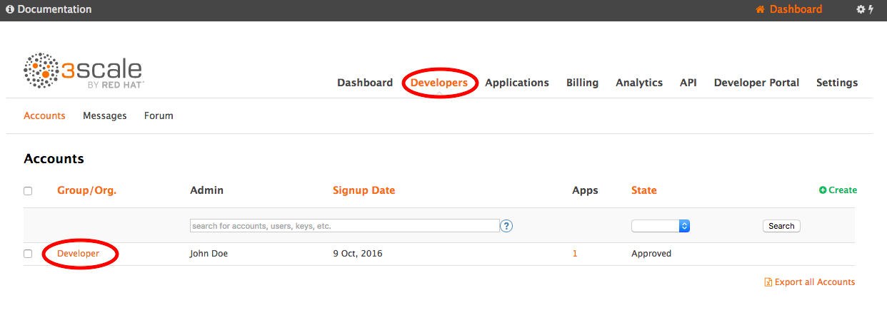
      * Click on the 1 User, click the user.  
        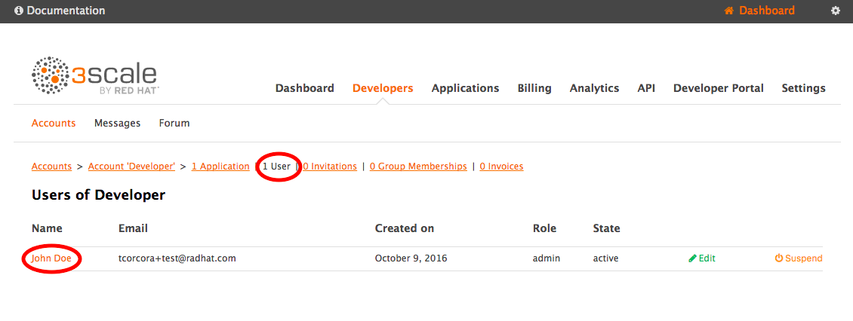
      * Edit then add a password and Update User  
        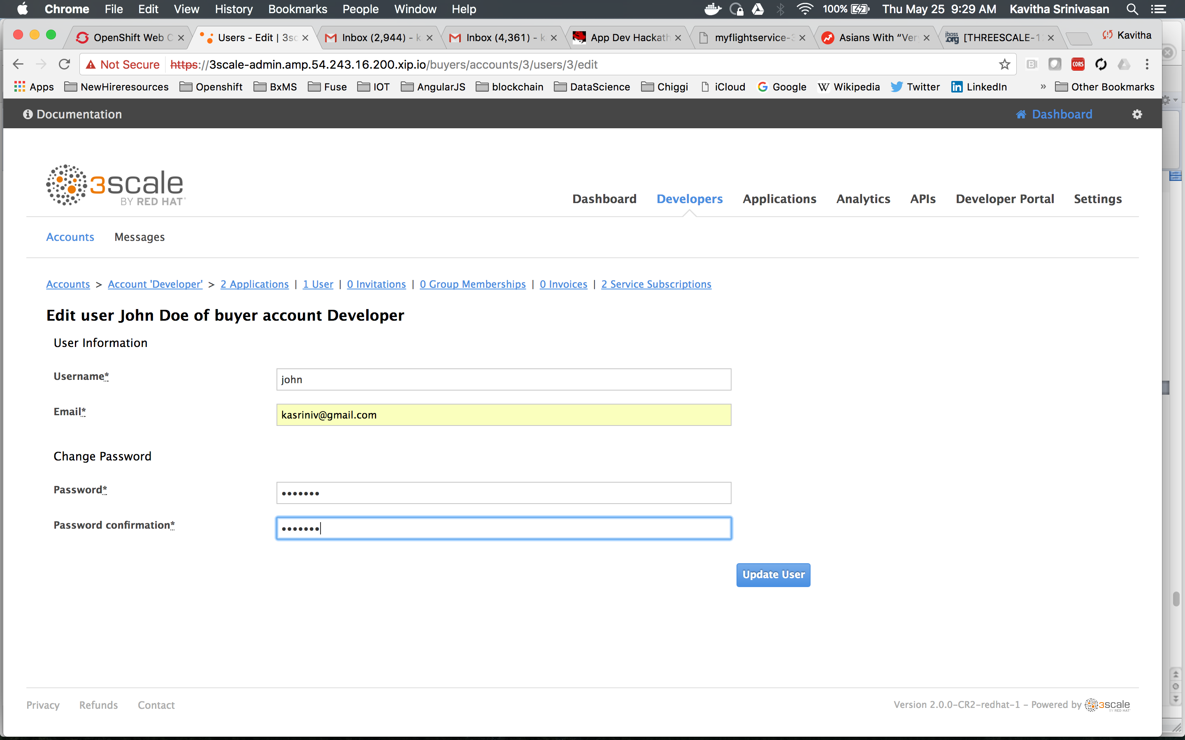
    - Login to the Dev Portal. Note be aware we are now switching the other web console – the one we setup for API Consumers, where ***users*** of the API (e.g. Expedia or CheapOAir) onboard and learn about the API.  
      * On Developer Portal Menu, click Visit Developer Portal. This is the out of the box Developer Portal.

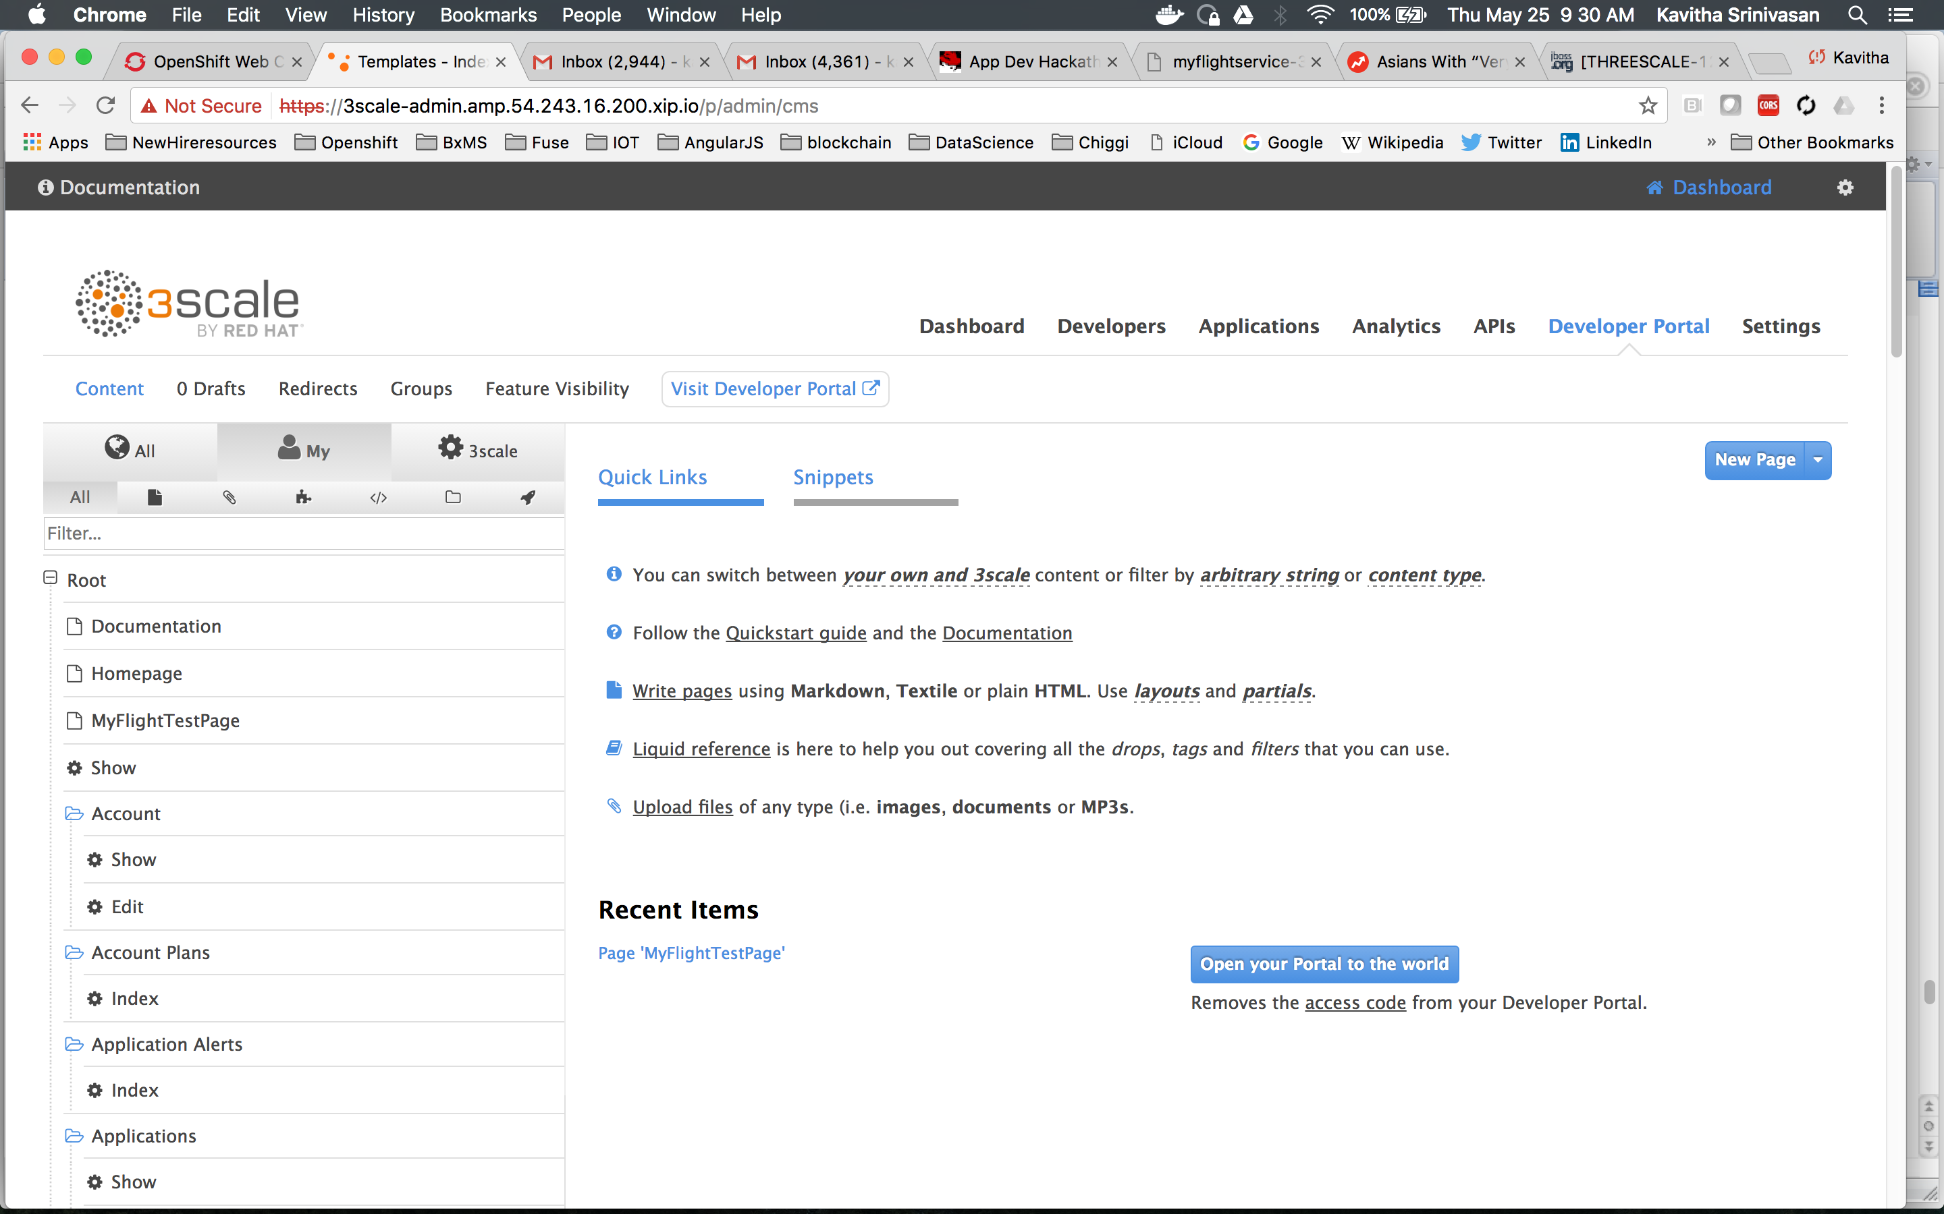  
  
  
  
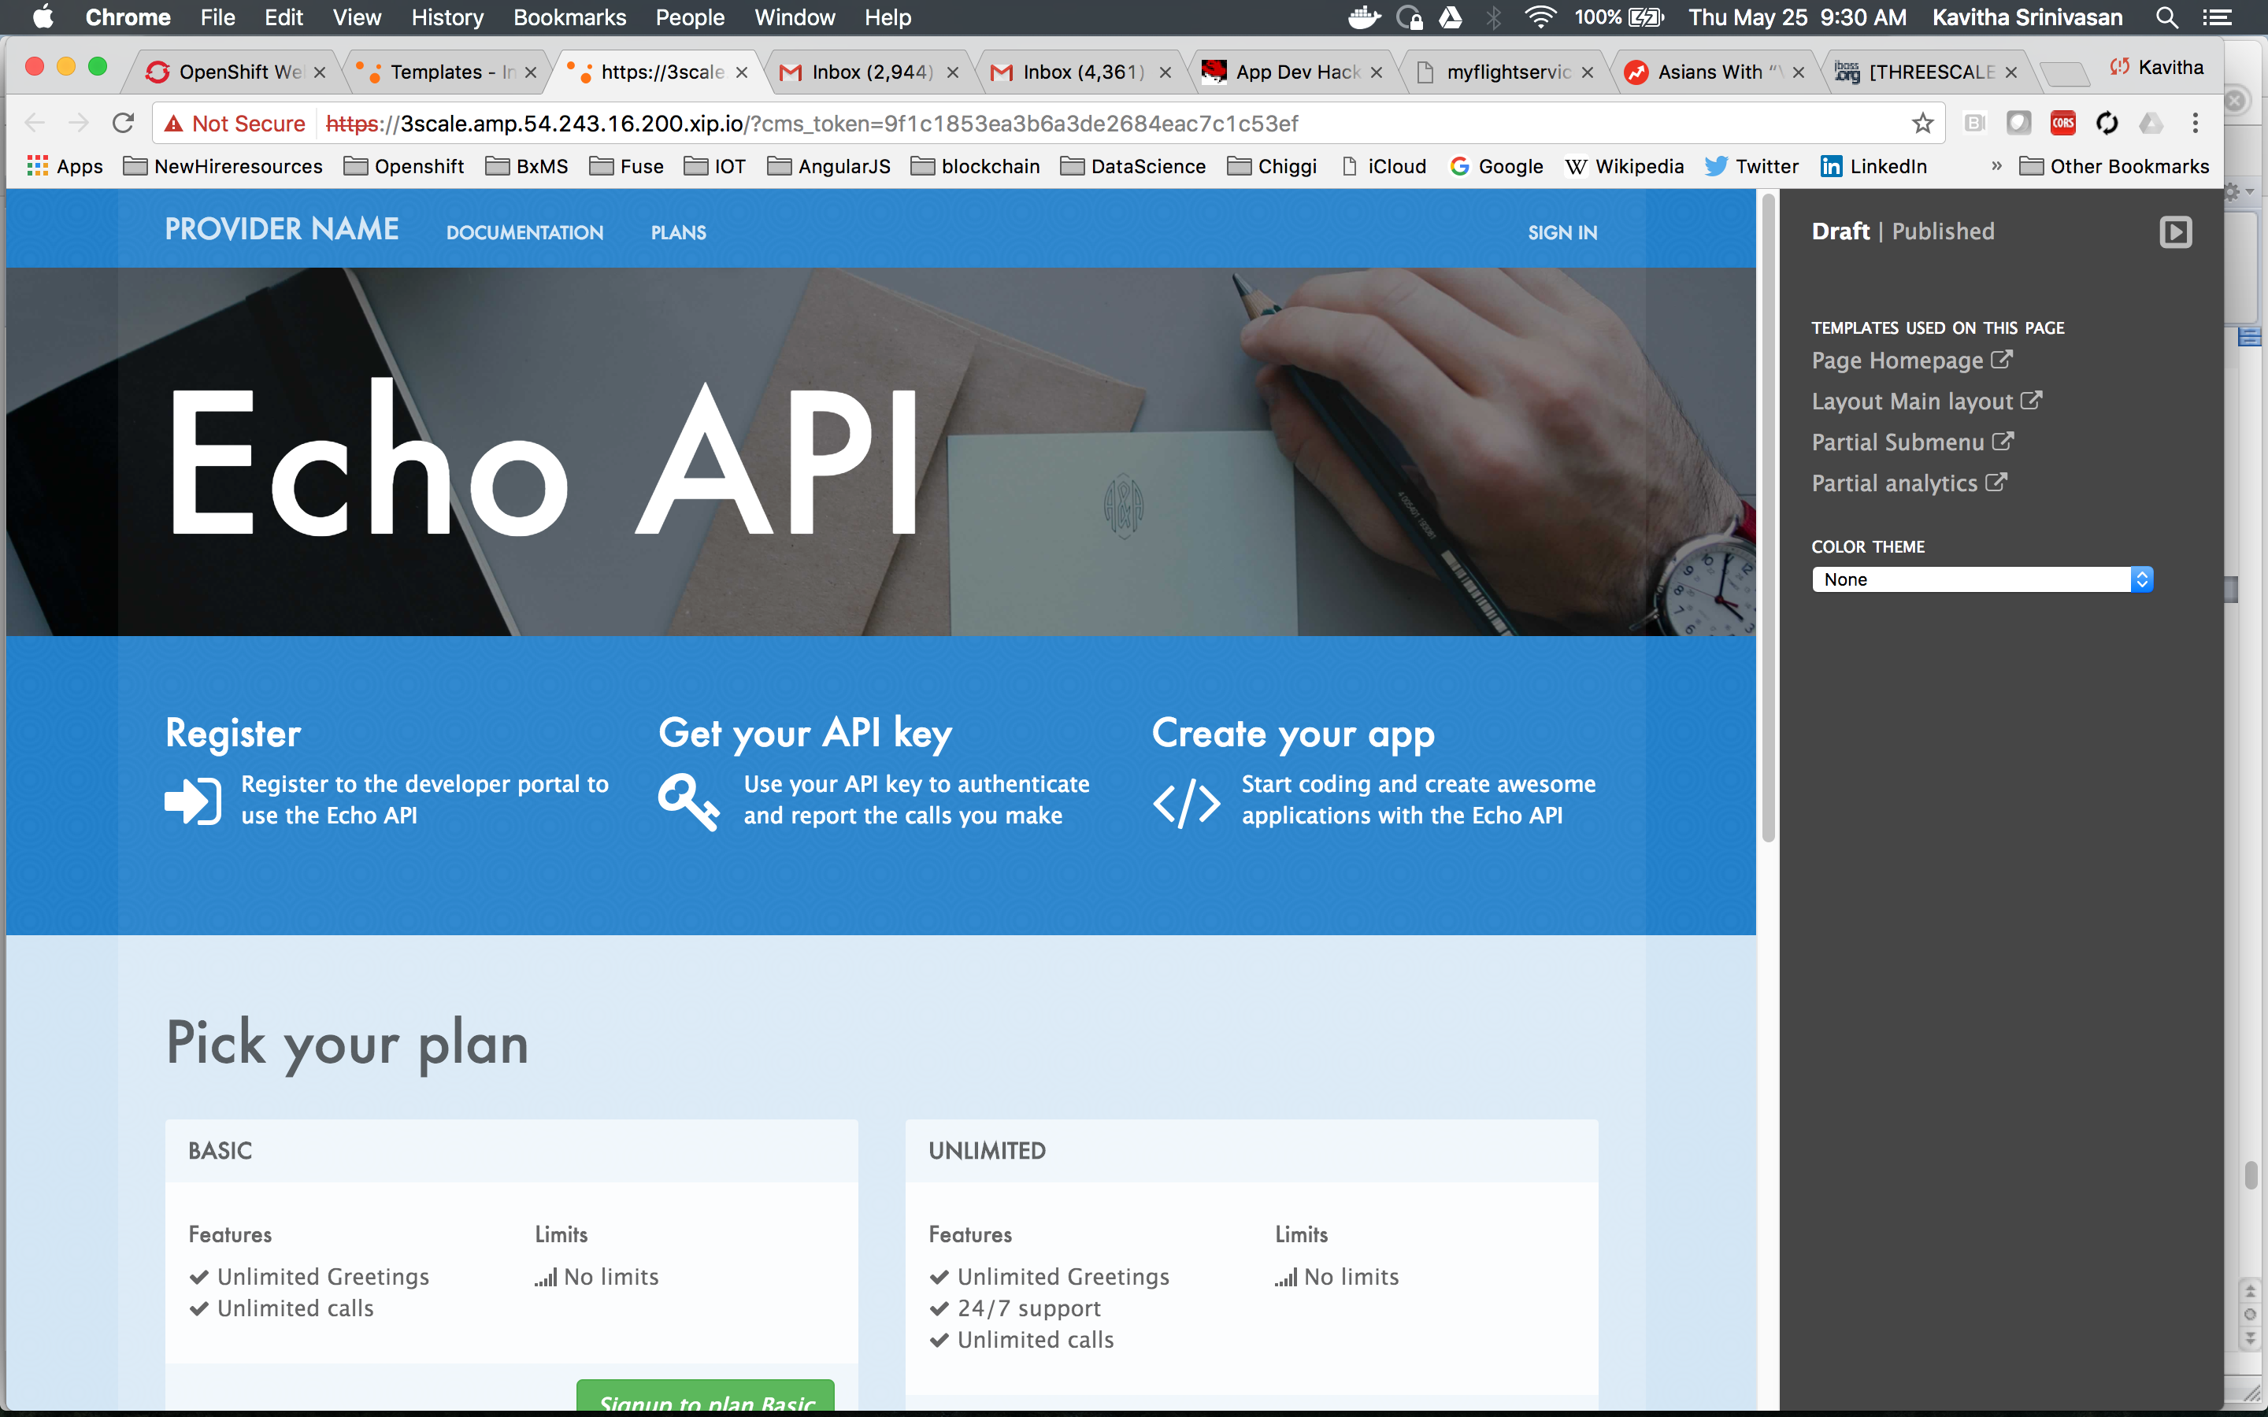

* + - * Sign in – using email and password of the user you just edited.
      * Inside Developer Portal, choose the Documentation menu or append the path you added to your Portal page you defined above and hit that URL, e.g. https://atlanta-training.3scale.net**/testdocs**  
        Swagger page appears like below

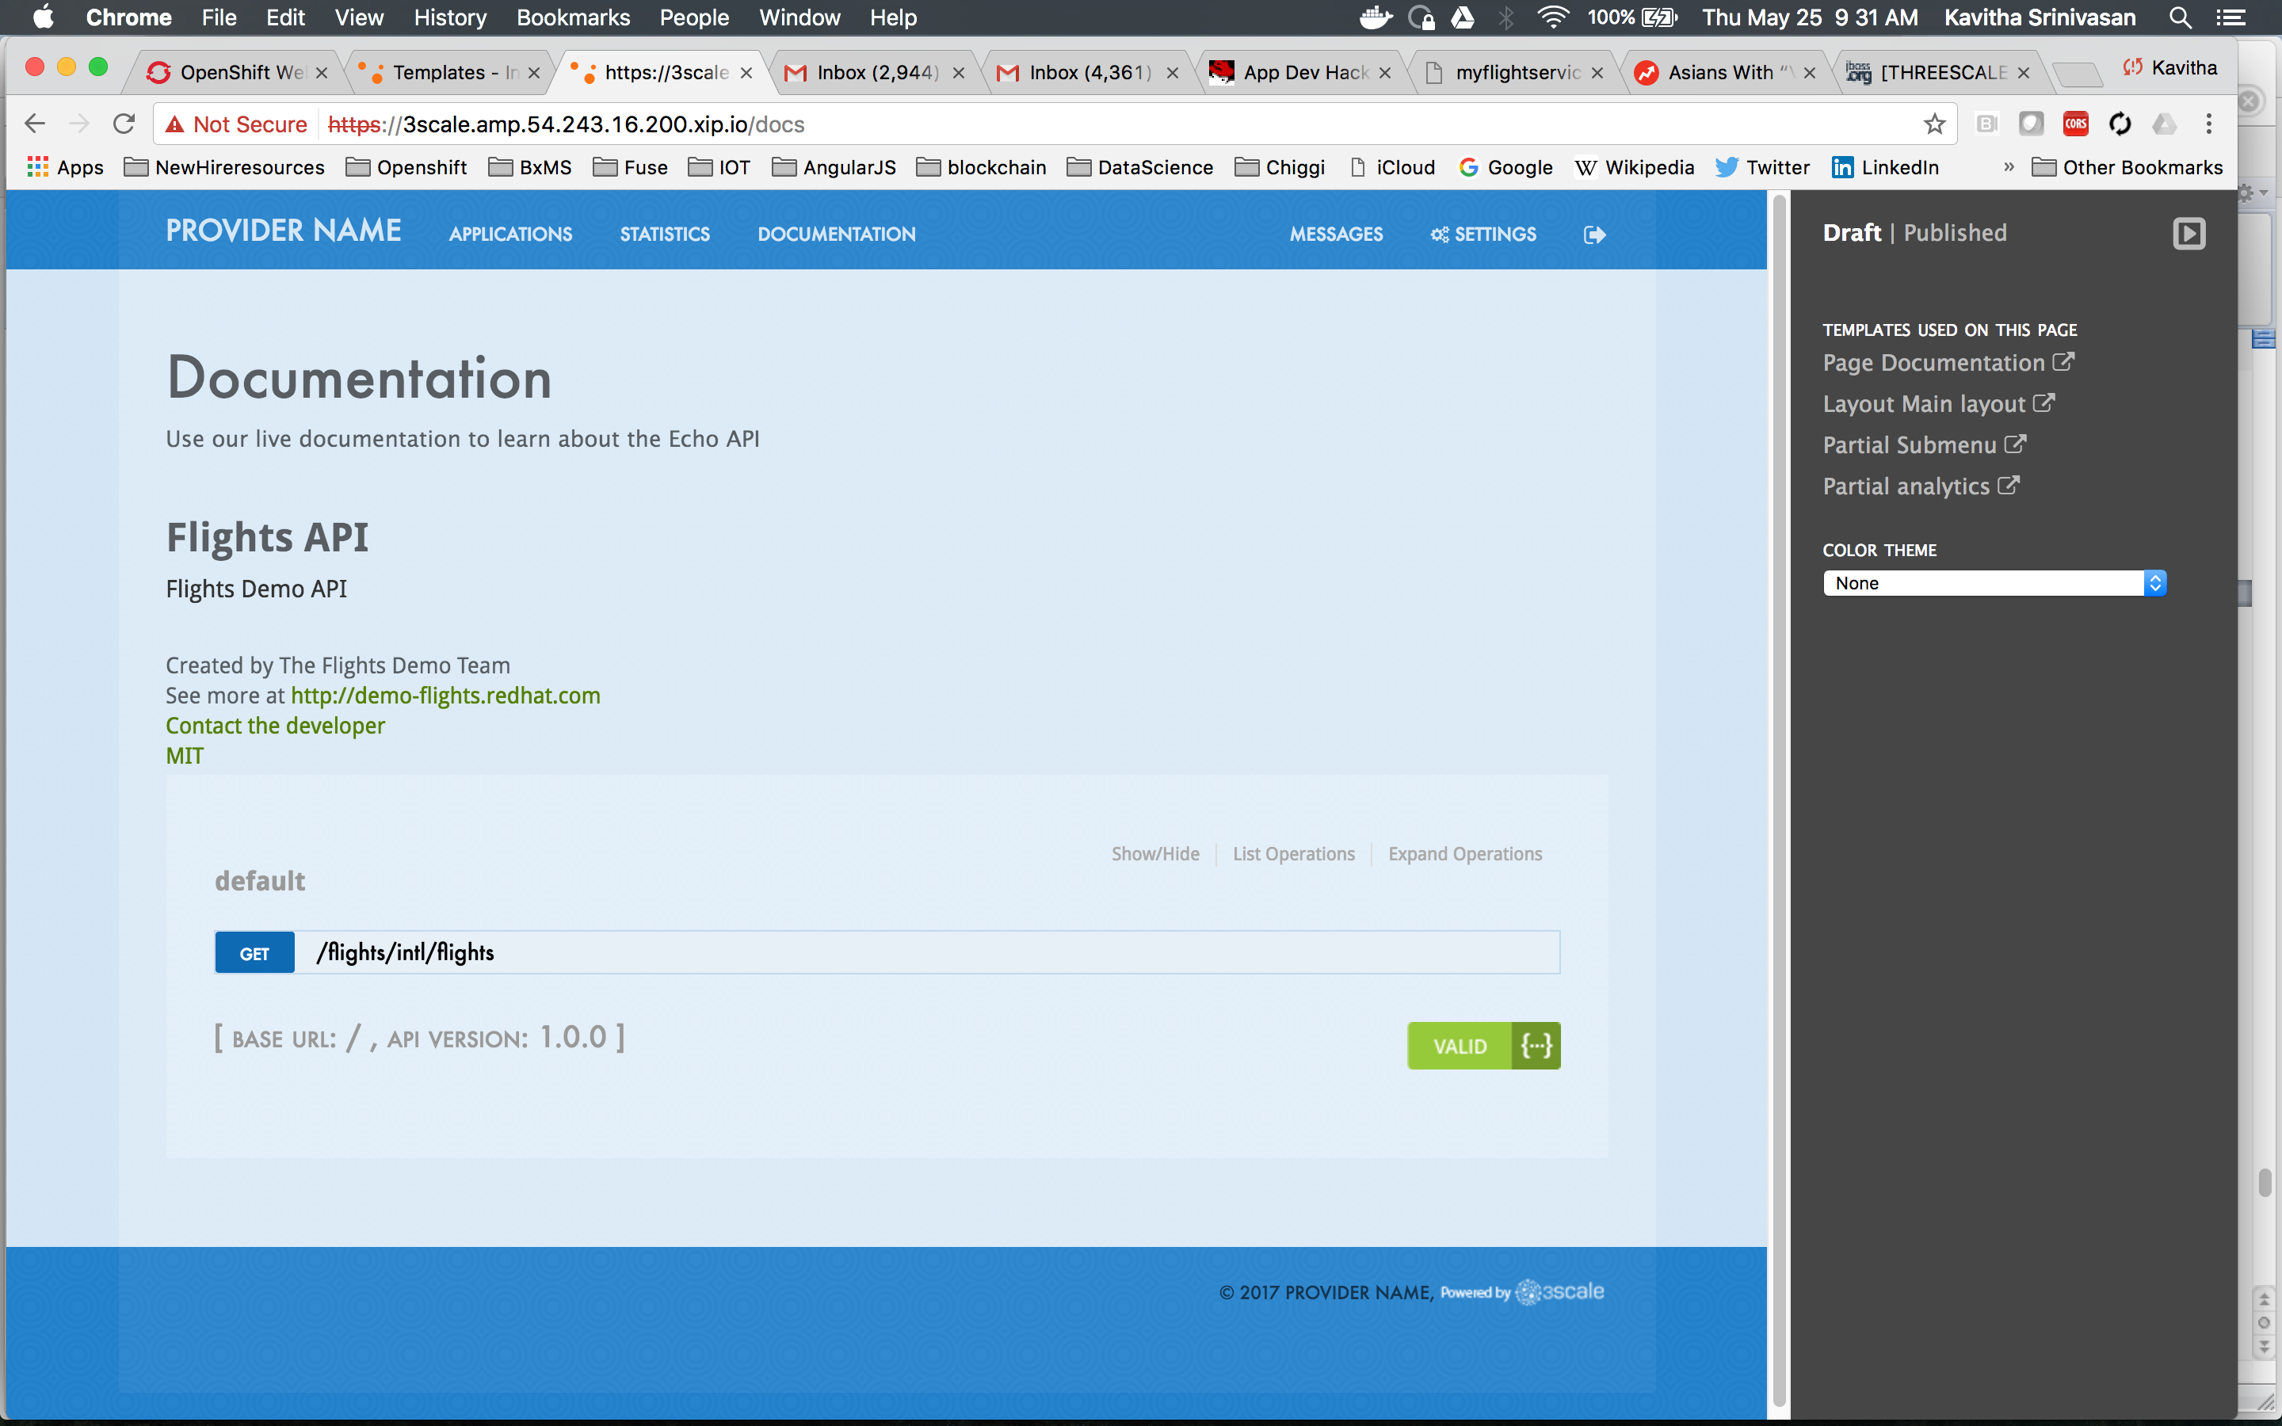

* + - * You can TRY IT OUT just like your developers would! (click on the /flights/intl/flights link)

## Step: Basic customization of the Developer Portal

* + - Add custom Logo – example of very basic Developer Portal customization.
      * Back in the Admin console, in the Developer Portal section, add a new File  
        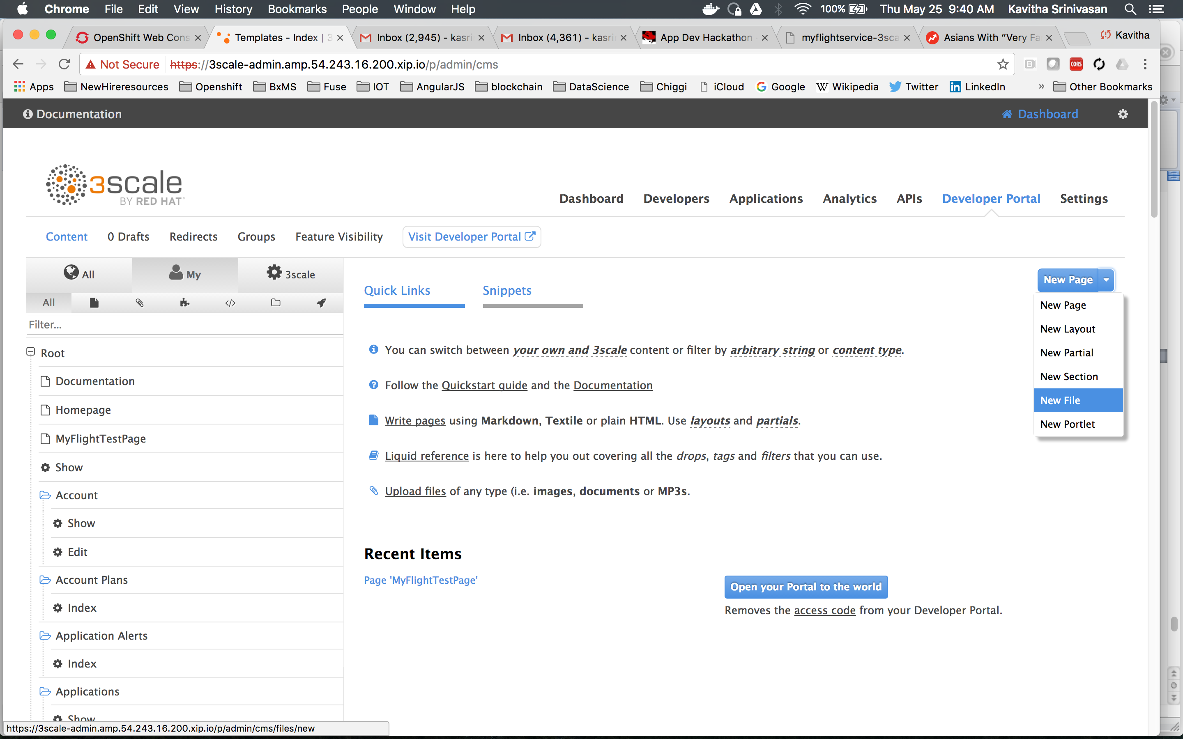
      * Set the **Section** to be *images* and the **Path** to be */images/Logo.png*, **Choose File** and browse to threescale-logo.png that accompanies this document (You’ll need to download it off the google drive and save it  
        locally on your hard drive first)

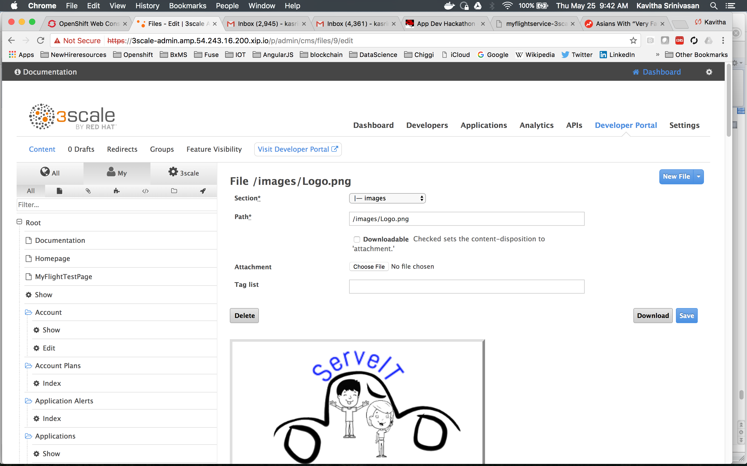  
‘Create File’ then ‘Save’

* + - * Now Add this file to the main layout page.  
        Scroll down and click the Main Layout – Left Hand Side near the bottom.  
        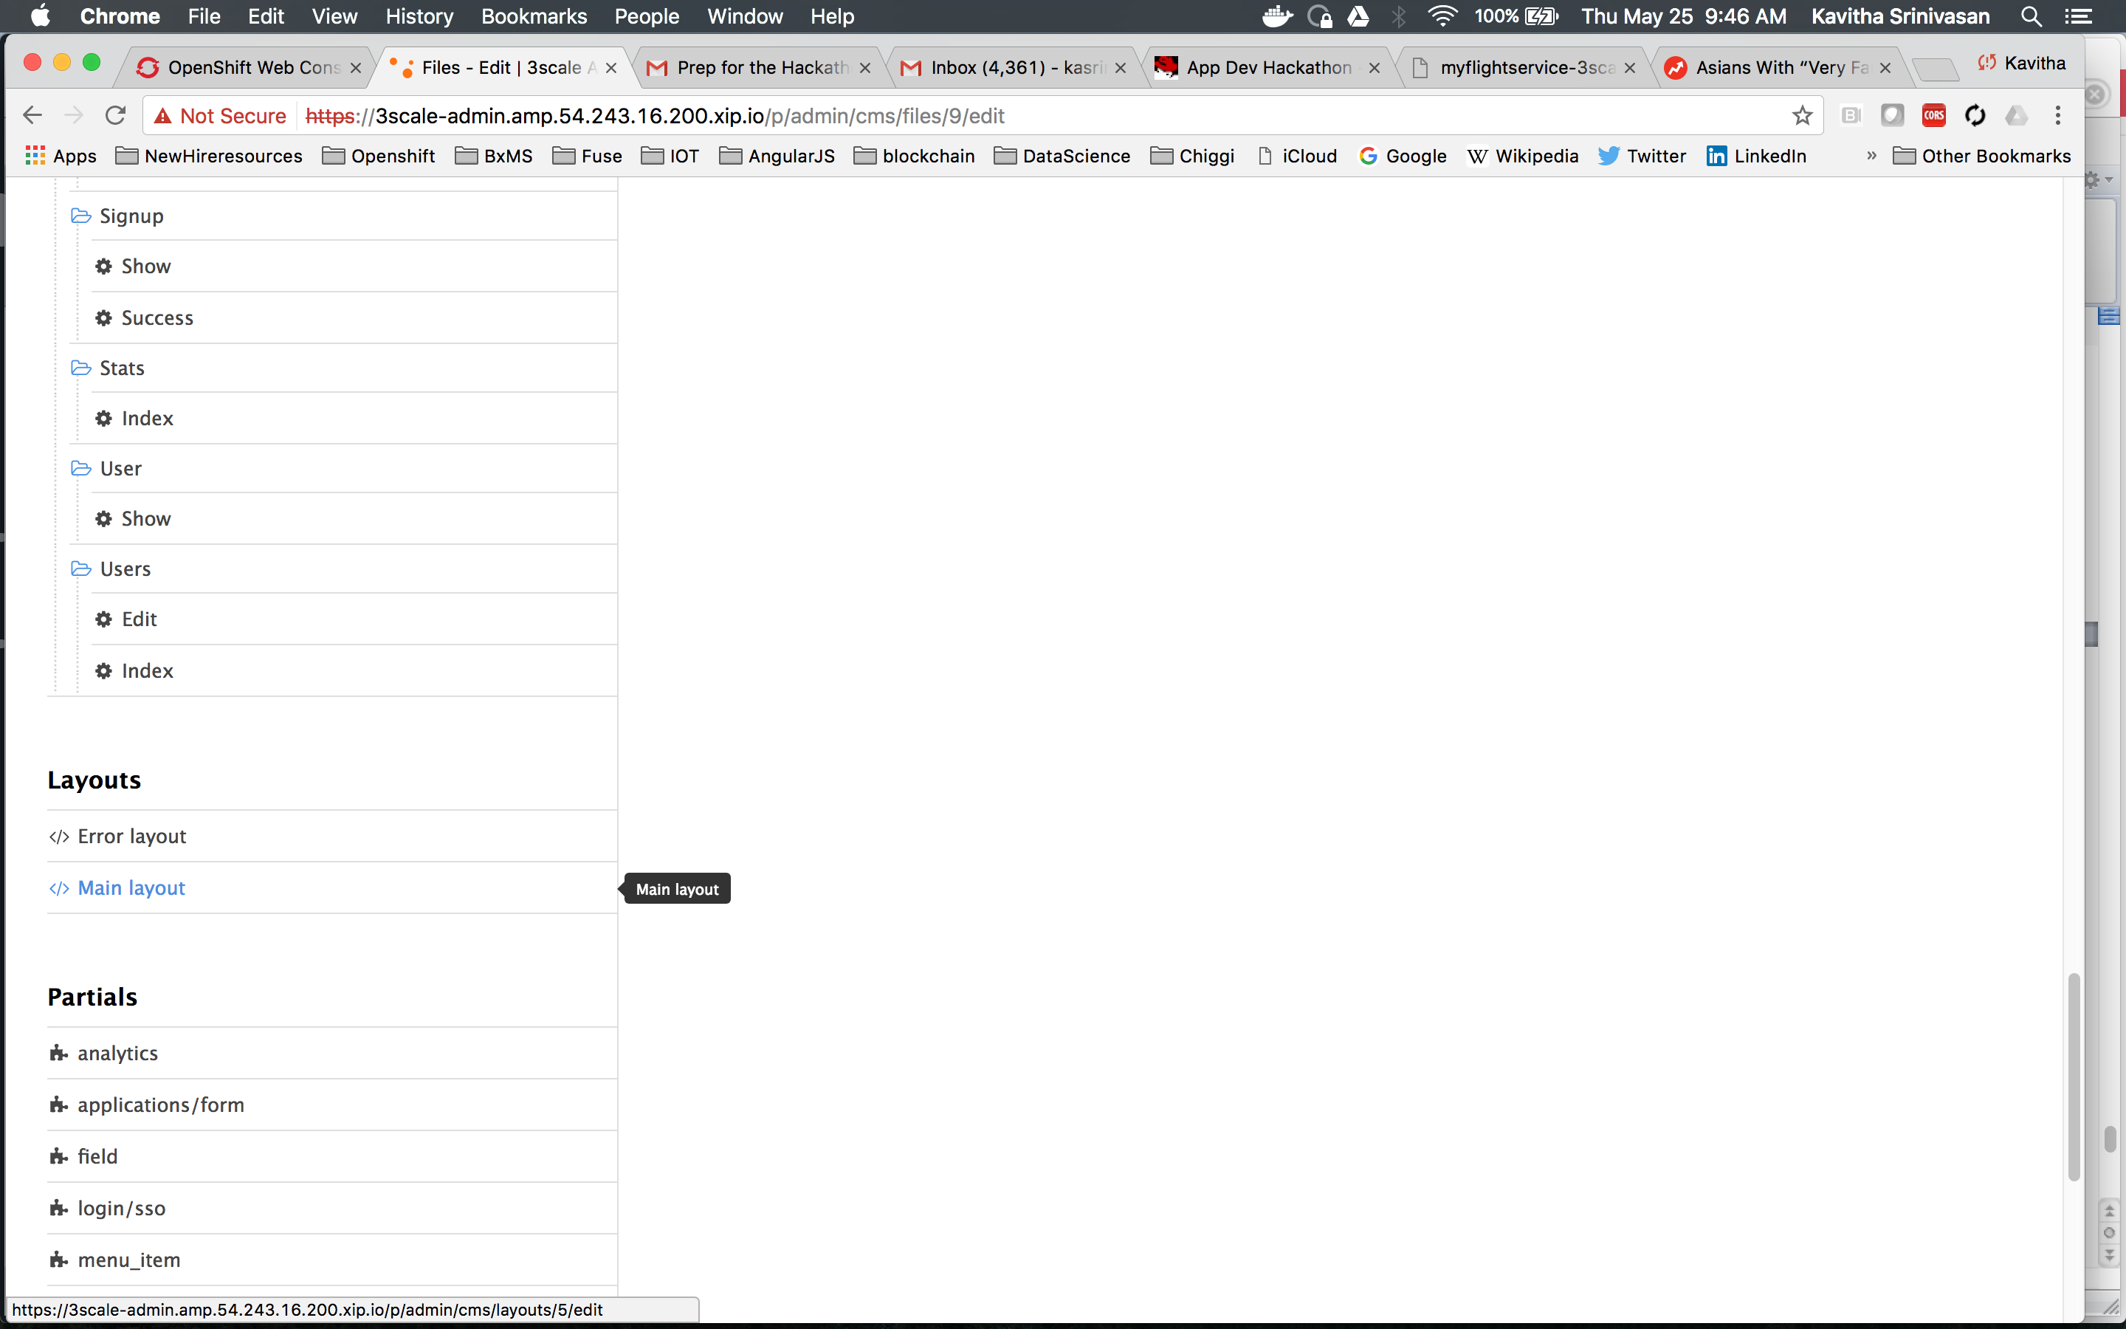

Line 46. Replace line: <a class="navbar-brand" href="/">{{ provider.name }}</a>

With:

<div class="logo">

<a href="#">

<img src="/images/threescale-logo.png " alt="" style="height:50px; width:150px;">

</a>

</div> ***Publish*** it.

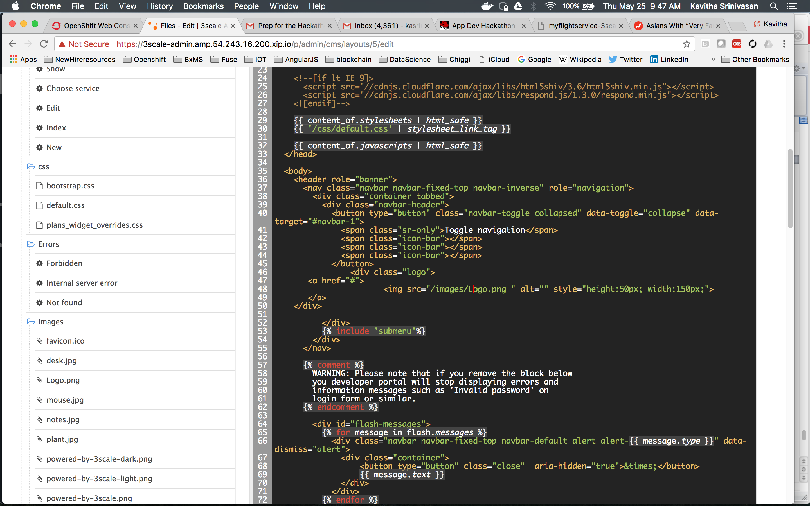

* + - * Go Back to the Dev Portal and refresh.

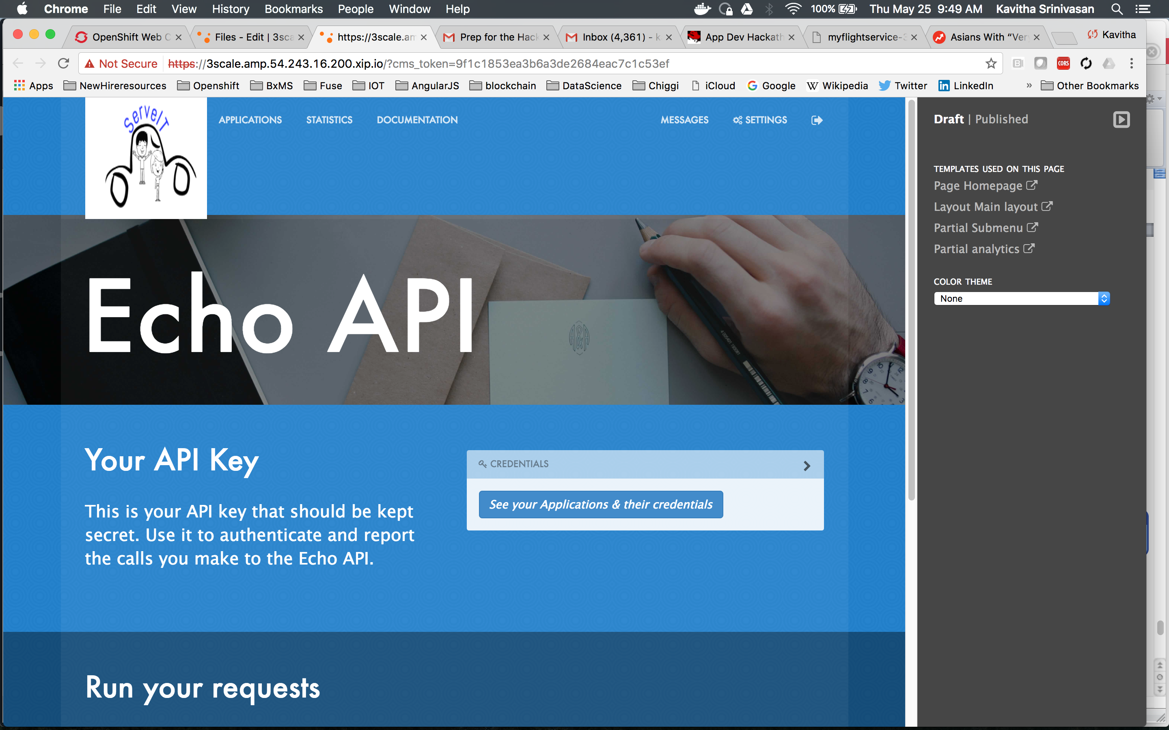

* + - * ADJUST THE WIDTH/HEIGHT (in red above) TO LOOK RIGHT

You’re done! You’ve completed the steps to do a minimal 3scale POC!

# **Appendix 1 – Swagger**

{

"swagger": "2.0",

"info": {

"version": "1.0.0",

"title": "Flights API",

"description": "Flights Demo API",

"termsOfService": "http://swagger.io/terms/",

"contact": {

"name": "The Flights Demo Team",

"email": "demo-flights@redhat.com",

"url": "http://demo-flights.redhat.com"

},

"license": {

"name": "MIT",

"url": "http://github.com/3scale/demo-flights/LICENSE-MIT"

}

},

"host": "yours.com",

"basePath": "/",

"schemes": [

"https"

],

"paths": {

"/flights/intl/flights": {

"get": {

"description": "Returns a list of flights",

"operationId": "Returns a list of flights",

"parameters": [

{

"name": "user_key",

"in": "query",

"description": "API/User Key",

"required": true,

"type": "string",

"x-data-threescale-name": "user_keys"

}

],

"responses": {

"200": {

"description": " Flights response",

"schema": {

"type": "object"

}

},

"403": {

"description": "Authentication failed",

"schema": {

"type": "object"

}

},

"default": {

"description": "unexpected error",

"schema": {

"type": "object"

}

}

}

}

}

},

"definitions": {

"flights": {

"type": "object"

},

"AuthenticationFailed": {

"type": "object"

},

"Error": {

"type": "object"

}

}

}

# **Appendix 2 – Dev Portal Swagger JavaScript**

<h3>Active Docs/Swagger 2.0 Documentation</h3>

{% active_docs version: "2.0" services: "<system-name>" %}

<script type="text/javascript">

$(function () {

window.swaggerUi.load();

});

</script>